**ST. ROSE CHURCH**

**ST. ROSE, IIlinois**

**Fr. Edward F. Schaefer**

18010 St. Rose Road

526-4118 Rectory

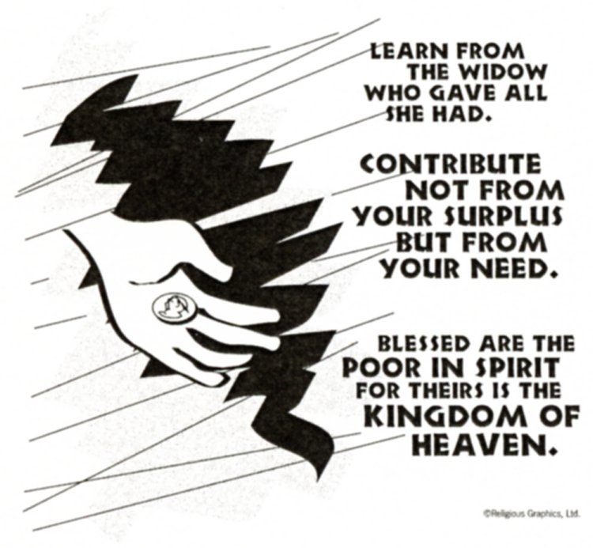

**SUNDAY MASS 10:00AM**

**SAT. VIGIL MASS 4:00PM**

**WEEKDAY MASS** **7:45AM**

**RECONCILIATION Saturday: 3:15 – 3:45PM**

**WEBPAGE:**  [www.strosechurchil.com](http://www.strosechurchil.com)

**EMAIL:** [belpsros@outlook.com](mailto:belpsros@outlook.com)

**FACEBOOK: St. Rose Catholic Church – St. Rose, IL**

**MASS WILL BE LIVE STREAMED ON OUR FACEBOOK PAGE SATURDAYS AT 4PM**

**SUNDAY COLLECTIONS:**

Weekly Envelopes: $3,403.00

All Saints: $295.00 Sister Parish: $ 170.00

Capital Improvement Fund: $1,545.00

**MASS:** **INTENTIONS:**

Mon 7:45AM St. Martin of Tours NO MASS

Tue 7:45AM St. Josaphat NO MASS

Wed 7:45AM St. Frances Xavier Cabrini Rev. Theodore Kamann

Thu 7:45AM Weekday NO MASS

Fri 7:45AM St. Albert the Great Jeanette Rehkemper

Sat 4:00PM Vigil: Thirty-Third Sunday in Ordinary Time L/D Ralph & Veronica Gall Family

“ “ “ “ “ L/DTheodore & Josephine Tebbe Family

“ “ “ “ “ Koerkenmeier Family

Sun 10:00AM Thirty - Third Sunday in Ordinary Time For the Parish

**SERVERS:**

Sat Nov 16 4:00PM Alaina Schrage, Seth Lane, Lexi Fuhler, Sam Fuhler

Sun Nov 17 10:00AM Ruby Jansen, Brady Jansen, Jacob Sturgeon, Nick Sturgeon

**READERS:** Sat Nov 16, 4:00PM Brenda Niedzwiecki Sun Nov 17, 10:00AM Mike Schumacher

**EUCHARISTIC MINISTERS:**

Sat Nov 16, 4PM Karla Tebbe Sun Nov 17, 10AM Jesse Thole & Ruth Holtgrave

**OFFERTORY:** Sat Nov 16, 4:00PM Gall, Tebbe & Koerkenmeier Families

Sun Nov 17, 10:00AM Don Tebbe, Ralph Tebbe, Ronald Wilke

**VOCATION CUP**: The next family to receive the Vocation Cup is the Mike Detmer family.

**CYM MEETING:** Sunday, Nov. 17th at 11AM. All HS students from the parish are welcome!

“HAVE YOU REMEMBERED ST. ROSE PARISH IN YOUR ESTATE PLANNING?”

**CONGRATULATIONS**: Levi Andrew Butler who was Baptized here last weekend.

Levi is the son of Allan Butler and Kristi Brinker. Many blessings to him!

**CONGRATULATIONS**: To the following St. Rose School First Quarter Honor Roll Students:

Bryna Harrison, Ava Sidwell, Ava Hilmes, Abbigail Leezer, Brianna Tebbe, Cole Timmermann,

Reagan Diekemper, Anna Henrichs, Mandy Poettker, Senya Rahden, Gavin Schneider, Alaina Schrage,

Raegen Alberternst, Everett Jansen, Rory Fehrmann, Ruby Jansen, Gavin Leezer, Aubree Ribbng,

Aria Tebbe, Aubrey Thole, James Tebbe, Will Timmermann, Paityn Fuhler, Rylan Schneider, Alaina Timmermann, Isabella Goebel, Greta Henrichs, Brady Jansen, Kelli Poettker & Zane Tebbe.

**CONGRATULATIONS**: To the following Central High School Cougars of the Month:

Kayley Burian, Danica Henrichs & Lily Thole.

**CONGRATULATIONS**: To the following Central High School First Quarter Honor Roll Students:

Grayce, Sturgeon, Landon Tebbe, Rylan Segert, Addison Tebbe, Peyton Markus, Loralei Schwierjohn,

Elizabeth Snyder, Mabry Benhoff, Emily Cirrincione, Jacey Robke, Rebecca Sturgeon, Lily Butler,

Brooke Harrison, Lillian Henrichs, Morgan Kapp, Paige Kapp, Reed Segert, Laney Tebbe,

Romayne Tebbe, Ava Strake, Jonathan Koch.

**CONGRATULATIONS**: To Nadia Baer and Claire Thole who were trained to serve as Extraordinary Ministers.

**ANNIVERSARIES:**

Nov 12 Daniel & Wanda Buehne ’02 Nov 12 Brian & Kristi Robke ‘05

Nov 12 Billy & Sheila Timmermann ’11 Nov 14 Derek & Megan Frey ‘20

Nov 15 Mark & Sherry Rehkemper ‘74

**CONGRATULATIONS**: To Mark & Sherry Rehkemper who are celebrating 50 years of marriage!

**BIRTHDAYS:**

Nov 11 Norma Rothengass Nov 13 Nora Schuette 10 Nov 15 Jason Peters

Nov 11 Renee Wilke Nov 13 Kaitlyn Smith Nov 15 Christina Gall

Nov 12 Zachary Gertsch Nov 14 Greg Jeckstadt Nov 16 Marvin Tebbe

Nov 12 Edna Grapperhaus Nov 15 Helen Detmer Nov 17 Wyatt Huelsmann 9

Nov 12 Michael Schrage Nov 15 Randy Fuhler Nov 17 Megan Thole

Nov 12 Melissa Tebbe Nov 15 Corynn Henrichs

**VOCATIONS CORNER:**

“Discovering vocation does not mean scrambling toward some prize just beyond my reach but accepting the treasure of true self I already possess. Vocation does not come from a voice out there calling me to be something I am not. It comes from a voice in here calling me to be the person I was born to be, to fulfill the original selfhood given me at birth by God.” – Thomas Merton

**CSMA UPDATE**: As of Oct. 31st 102 families from St. Rose have donated a total of $18,985.00.

**WHEATFIELD TWP. FIRE DEPT. DRIVE THRU PORK CHOP DINNER:**

Sunday, Nov 10th 11AM to 5PM at the church hall in Beaver Prairie. $15

**DIOCESE OF BELLEVILLE YOUNG ADULTS PRESENTS BIBLES AND BREW:**

Thursday, Nov 14th 6:30PM – 7:00PM Social & 7:00PM – 8:30PM Event

For young adults 21-35 at the Tavern On Main, Belleville. More information at bellevilledioceseyoungadults.com

**THANKSGIVING DAY DINNER**:

At St. Henry’s Catholic Church Msgr. Voss Parish Center in Belleville from 10:45AM till noon on Thanksgiving Day. Call for reservations at 618-722-5024 before Nov. 20. No carry-outs,

**CATHOLIC CAMPAIGN FOR HUMAN DEVELOPMENT (CCHD):**

Please be generous in this week’s special collection for the CCHD. This collection supports programs

that address the root causes of poverty across the country. Twenty-five percent of the funds collected

remain in our diocese to fund local anti-poverty programs. If you know of a grassroots community or economic development program that could benefit from CCHD funding contact CCHD Director,

Cheryl Sommer at cchddiobelle@gmail.com