**ST. ROSE CHURCH**

**ST. ROSE, IIlinois**

**Fr. Edward F. Schaefer**

18010 St. Rose Road

526-4118 Rectory

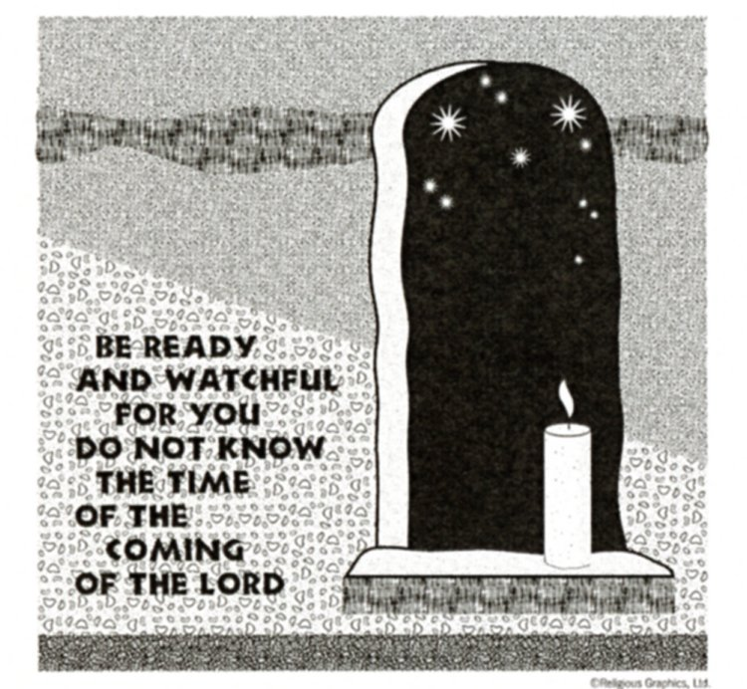

**SUNDAY MASS 10:00AM**

**SAT. VIGIL MASS 4:00PM**

**WEEKDAY MASS** **7:45AM**

**RECONCILIATION Saturday: 3:15 – 3:45PM**

**WEBPAGE:**  [www.strosechurchil.com](http://www.strosechurchil.com)

**EMAIL:** [belpsros@outlook.com](mailto:belpsros@outlook.com)

**FACEBOOK: St. Rose Catholic Church – St. Rose, IL**

**MASS WILL BE LIVE STREAMED ON OUR FACEBOOK PAGE SATURDAYS AT 4PM**

**SUNDAY COLLECTIONS:**

Thanksgiving: $25.00 Weekly Envelopes: $2,711.00

All Saints: $40.00 Sister Parish: $ 21.00

CCHD: $165.00 Capital Improvement Fund: $ 677.00

**MASS:** **INTENTIONS:**

Mon 7:45AM St. Catherine of Alexandria NO MASS

Tue 7:45AM Weekday NO MASS

Wed 7:45AM Weekday Rev. Edwin Kastner

**Thu 9:00AM THANKSGIVING DAY** Roger Henrichs

“ “ Koerkenmeier Family

Fri 7:45AM Weekday NO MASS

Sat 4:00PM Vigil: First Sunday of Advent L/D Frank & Elsie Thole Family

“ “ “ Alfred, Lucy & Gary Korte

“ “ “ EJ, Rita & Ken Schrage

Sun 10:00AM First Sunday of Advent For the Parish

**SERVERS:**

**Thursday Nov 28** 9:00AM Theodore Tebbe & Volunteers

Sat Nov 30 4:00PM Lexi Fuhler, Sam Fuhler, Ava Sidwell, Ally Butler

Sun Dec 1 10:00AM Wade Kramer, Briggs Kramer, William Timmermann, Lauryn Vonder Haar

**READERS:** **Thursday Nov 28, 9:00AM** Jeff Kampwerth

Sat Nov 30 4:00PM Don Henrichs Sun Dec 1 10:00AM Kayden Barriger

**EUCHARISTIC MINISTERS:**

**Thursday Nov 28 9:00AM** Rose Rensing

Sat Nov 30, 4PM Lisa Baer Sun Dec 1, 10AM John & Kate Kohlbrecher

“HAVE YOU REMEMBERED ST. ROSE PARISH IN YOUR ESTATE PLANNING?”

**HAPPY THANKSGIVING!**

**OFFERTORY:**

**Thursday Nov 28 9:00AM** Henrichs & Koerkenmeier Families

Sat Nov 30 4:00PM Thole, Korte & Schrage Families

Sun Dec 1 10:00AM Alfred Holtgrave, Dale Timmermann, Brent Timmermann

**VOCATION CUP**: The next family to receive the Vocation Cup is the Robert Detmer Family.

**CONGRATULATIONS TO THE ST. ROSE WILDCATS OF THE MONTH:**

Jackson Thole, Elsie Thole, Paityn Fuhler and Violet Tucker.

**ANNIVERSARIES:**

Nov 26 Robert & Pamela Schuette ’82 Nov 27 Virgil & Sue Tebbe ‘69

Nov 28 Brian & Diana Dulle ’97 Nov 28 Karl & Lori Winkeler ‘98

Nov 30 Marvin & Connie Potthast ‘74

**BIRTHDAYS:**

Nov 25 Shirley Schumacher Nov 28 Lorraine Henrichs Nov 30 Emma Koch 20

Nov 25 John Tebbe Nov 28 Kelly Voss Dec 01 Barbara Harrison

Nov 26 Richard Harrison Nov 28 Lucas Wilke Dec 01 Bo Rakers 8

Nov 26 Mark Steinmann Nov 29 Robert Detmer Dec 01 Jonah Toennies

Nov 27 Ed Eilers Nov 29 Rebecca Henrichs Dec 01 Sage Wiegmann

Nov 27 John Kalmer Nov 29 Jason Koerkenmeier

Nov 27 Kyle Poettker Nov 29 Agnes Schrage

**PSR AIDE NEEDED FOR 6TH GRADE:**

If interested, please call Sydney at 618-719-0698

**VOCATIONS CORNER:**

This coming week we celebrate a National Day of Thanksgiving. We, Catholics, give even greater thanks for all the gifts that God has bestowed on us and for us to share. Each one of us has been given a unique calling to Holiness. Each one is to serve the Lord in her/his own “called” way. A vocational calling is asking us to surrender our talents to God so that they may be sanctified and produce fruit for the Kingdom.

**THANKSGIVING DAY DINNER**:

At St. Henry’s Catholic Church Msgr. Voss Parish Center in Belleville from 10:45AM till noon on Thanksgiving Day. Call for reservations at 618-722-5024 before Nov. 20. No carry-outs,

**THANKSGIVING FOOD DRIVE FOR THE HOUSE OF MANNA:**

Baskets will be located at all entrances to church. Please bring your donations no later than Dec 2nd.

**CHRISTMAS GIFTS FOR THE NEEDY:**

Once again we will be accepting Christmas gifts for the needy. Names will be in envelopes at

all entrances to church. **PLEASE**, return your gift no later than Sunday, December the 8th.

We also have envelopes with donations for Catholic Relief Service if you wish to donate to them.

**ADVENT RECONCILIATION SERVICES:**

Dec 01 St Damian, Damiansville 1:00PM Dec 04 St. Mary, Centralia (School) 12:30PM

Dec 08 St. Mary, Centralia 1:00PM Dec 10 St. Rose, St. Rose 7:00PM

Dec 11 St. Mary, Trenton 7:00PM Dec 12 St. Theresa, Salem 6:30PM

Dec 12 St. Augustine, Breese 7:00PM Dec 13 St. Ann, Nashville 6:00PM

Dec 15 St. Mary, Mt. Vernon 1:00PM Dec 15 St. Boniface, Germantown 2:00PM

Dec 15 St. Francis, Aviston 6:00PM Dec 19 St. Mary, Carlyle 6:00PM

Dec 19 OLPH, Posen 6:15PM Dec 22 St. Charles Borromeo, DuBois 3:00PM

Dec 22 St. Michael, Radom 6:00PM

**CATHOLIC SERVICE AND MINISTRY APPEAL (CSMA):**

On behalf of the ministries & programs funded by the CSMA and those they serve, we thank you for

your prayers & continued generosity to the 2024 campaign. May you and your families feel the warmth

of God’s love & the comfort of His peace at Thanksgiving and always.