**ST. ROSE CHURCH**

**ST. ROSE, IIlinois**

**Fr. Edward F. Schaefer**

18010 St. Rose Road

526-4118 Rectory

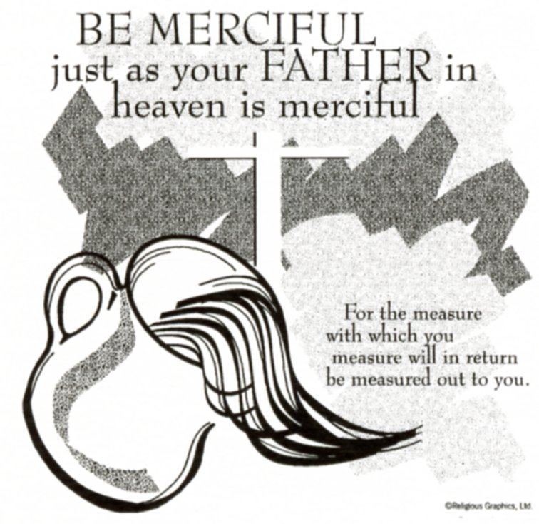

**SUNDAY MASS 10:00AM**

**SAT. VIGIL MASS 4:00PM**

**WEEKDAY MASS** **7:45AM**

**RECONCILIATION Saturday: 3:15 – 3:45PM**

**WEBPAGE:**  [www.strosechurchil.com](http://www.strosechurchil.com)

**EMAIL:** [belpsros@outlook.com](mailto:belpsros@outlook.com)

**FACEBOOK: St. Rose Catholic Church – St. Rose, IL**

**MASS WILL BE LIVE STREAMED ON OUR FACEBOOK PAGE SATURDAYS AT 4PM**

**SUNDAY COLLECTIONS:**

Weekly Envelopes: $2,878.00

Donations: $1,320.00 Cemetery Donations: $300.00 Sister Parish: $ 130.00

Capital Improvement Fund Donations: $200.00 Capital Improvement Fund: $ 705.00

**MASS TIMES** **MASS INTENTIONS:**

Mon 7:45AM Weekday NO MASS

Tue 7:45AM Weekday NO MASS

Wed 7:45AM Weekday Butch & Joan Kohlbrecher

**T**hu 7:45AM St. Gregory of Narek NO MASS

Fri 7:45AM Weekday Leonard Klostermann

Sat 4:00PM Vigil: Eighth Sunday in Ordinary Time For the Parish

Sun 10:00AM: Eighth Sunday in Ordinary Time Bill & Ann Alberternst

“ “ “ “ Jim Fuhler

“ “ “ “ Gerp Henrichs

**SERVERS:**

Sat Mar 1 4:00PM Cole Timmermann, Alaina Timmermann, Mandy Poettker, Kelli Poettker

Sun Mar 2 10:00AM Ruby Jansen, Brady Jansen, Lauryn Vonder Haar, Ava Sidwell

**READERS:** Sat Mar 1 4:00PM Kampwerth Sun Mar 2 10:00AM Pam Andrews

**EUCHARISTIC MINISTERS:**

Sat Mar 1 4:00PM Gail Tebbe Sun Mar 2 10:00AM Margie Tebbe & Mel Thole

**OFFERTORY:**

Sat Mar 1 4:00PM Vince Tebbe, Tom Harper, Terry Snyder

Sun Mar 2 10:00AM Alberternst, Fuhler & Henrichs Families

**VOCATION CUP**: The next family to receive the Vocation Cup is the Mark Faust Family.

**CYM MEETING**: **THIS** Sunday, Feb 23rd at 11AM in the Convent.

“HAVE YOU REMEMBERED ST. ROSE PARISH IN YOUR ESTATE PLANNING?”

**SYMPATHY**: Our sympathy to the family of James “Jim” Straeter. Jim, who passed away recently,

was the Brother of Marge (Mike) Detmer and the Uncle of John (Kelly) Detmer, Justin (Lisa) Detmer and

Renee (Mark) Steinmann. May Jim enjoy the reward of eternal life!

**SYMPATHY**: Our sympathy to the family of Pete Boeing. Pete who passed away this week, was the

Father of Dan (Donna) Boeing and the Grandfather of Dee and Dominic Boeing. May Pete enjoy the reward of eternal life!

**MATER DEI HIGH SCHOOL:** Monday, Feb. 24th @ 7PM Fathers & Friends Meeting

**ST. ROSE DEVELOPMENT CLUB BANQUET**: Saturday, March 1st

**ANNIVERSARIES:**

Feb 26 Trevor & Sierra Koerkenmeier ’22 Feb 26 Bill & Amanda Rauen ‘11

Feb 29 Thomas & Kathleen Altgilbers ‘80

**CONGRATULATIONS**: To Thomas & Kathleen Altgilbers who are celebrating 45 years of marriage.

**BIRTHDAYS:**

Feb 24 Maggie Alberternst 6 Feb 25 Jennifer Sturgeon Mar 1 Debbie Fuhler

Feb 24 Kim Goebel Feb 27 Colby Detmer 18 Mar 1 Tammy Kampwerth

Feb 24 Adelyn Taylor 6 Feb 27 Lydia Thole 15 Mar 1 James Richter

Feb 24 Jaydon Tebbe 19 Feb 27 Chad Vonder Haar Mar 2 Lillian Henrichs 17

Feb 24 Timothy Wilke Feb 28 Diana Dulle Mar 2 Marissa Jansen 15

Feb 25 Lauren Gnaedinger 7 Feb 28 Emma Heinzmann 6 Mar 2 Marilyn Rehkemper

Feb 25 Scott Poettker Feb 28 Kathleen Klostermann Mar 2 Lauren Schumacher

Feb 25 Steely Rehkemper 3 Feb 28 James Kuper 13 Mar 2 Elizabeth Scott 19

Feb 25 Naomi Schuette 5 Feb 28 Blake Monken 18 Mar 2 Lisa Smith

Feb 25 Judith Spihlman Feb 28 Leona Thole Mar 2 Dan Tebbe

**VOCATIONS CORNER:**

“People often discover their vocation to religious life at Mass or in adoration, but I “heard the call” while literally receiving a phone call! Before this life-changing moment during my last semester of college, I had spent about a

year growing in my spiritual life through spiritual direction & getting to know members of Pro Ecclesia Santa.

I was attracted to their joy, their charism to live & promote holiness and their closeness to the Sacred Heart.

But I was wrestling with the question of whether God was really calling me to religious life. Speaking on the phone with a potential roommate for the following year, I knew deep down that I was fooling myself. I didn’t need to make housing plans; God wanted me to say “yes” to my vocation and move in with the sisters. Whatever your state of life, say “yes” to God’s will and let yourself be surprised by His loving plans for you.”

Sister leann Luecke; Pro Ecclesia Santa

***BREESE AMERICAN LEGION CHICKEN DINNER:* THIS** Sunday, Feb 23rd from 11AM to 5PM.

**YOUNG ADULT CATHOLIC SPEED DATING:**

For ages 21-33 on Thursday, Feb. 27th at Holy Trinity Parish, Fairview Heights. Check in 6:30PM and Event from 7PM to 9:30PM. For questions, contact mskorch@diobelle.org.

**ST. DAMIAN MEXICAN FISH FRY:**

Friday, Feb 28th from 4:30PM to 7:30PM at St. Damian Gym in Damiansville.

Mariachi Band from 5-7PM. Dine in or carry out available. One night and CASH only.

**A GREAT OPPORTUNITY FOR YOUR LENT THIS YEAR!**

A Video Series on the Gospel of LUKE: THE STORY OF SALVATION FULFILLED! Each TUESDAY

of Lent at 7PM in the Development Club Building beginning March 11th. This special series will enrich your everyday life. JOIN US AND BRING A FRIEND. Call Marilyn Burggemann 618-210-1258 or

Myrt Rollins 314-707-7063.

**IMMACULATE CONCEPTION CHURCH, PIERRON DRIVE-THROUGH CHICKEN DINNER;**

Sunday, March 2nd 11AM to 5PM. All dinners $15.

**MATER DEI BASEBALL CAMP:**

Baseball camp (grades3-8) on Sunday, March 2nd from 12PM to 2:30PM. Cost if $40 for an individual & $60 for

2 or more campers from the same family. Information & Registration forms (online and printable) on the Mater Dei website: [www.materdeiknights.org/camp-baseball](http://www.materdeiknights.org/camp-baseball).