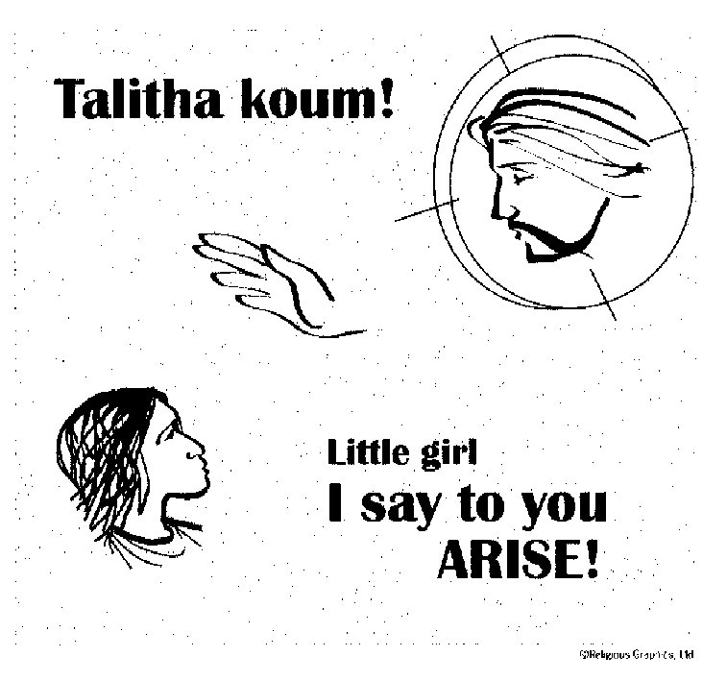

**ST. ROSE CHURCH**

**ST. ROSE, IIlinois**

**Fr. Edward F. Schaefer**

18010 St. Rose Road

526-4118 Rectory

**SUNDAY MASS 10:00AM**

**SAT. VIGIL MASS 4:00PM**

**WEEKDAY MASS**  **8:00AM**

**RECONCILIATION Saturday: 3:15 – 3:45PM**

**WEBPAGE:**  [www.strosechurchil.com](http://www.strosechurchil.com)

**EMAIL:** [belpsros@outlook.com](mailto:belpsros@outlook.com)

**FACEBOOK: St. Rose Catholic Church – St. Rose, IL**

**MASS WILL BE LIVE STREAMED ON OUR FACEBOOK PAGE SATURDAYS AT 4PM** **SUNDAY COLLECTIONS:**

Weekly Envelopes: $2,289.00

Sister Parish: $ 25.00

**MASS:** **INTENTIONS:**

Mon 8:00AM St. JuniperoSerra NO MASS

Tue 8:00AM Weekday NO MASS

Wed 8:00AM St. Thomas, Apostle Larry Straeter

Thu 8:00AM Weekday NO MASS

Fri 8:00AM St. Anthony Zaccaria & St. Elizabeth of Portugal John & Bea Tebbe

Sat 4:00PM Vigil Fourteenth Sunday in Ordinary Time Butch & Joan Kohlbrecher

“ “ “ “ Clare Schaefer

“ “ “ “ Jim Tebbe

Sun 10:00AM The Fourteenth Sunday in Ordinary Time For the Parish

**SERVERS:**

**Wed. July 3 8:00AM** Need Volunteers

**Fri. July 5 8:00AM** Need Volunteers

Sat July 6 4:00PM Mandy Poettker, Kelli Poettker, Cal Strotheide, Ryce Strotheide

Sun July 710:00AM Caitlyn Vonder Haar, Lauryn Vonder Haar, Cole Timmermann, Alaina Timmermann

**READERS:**

Sat 4PM Jeff Kampwerth Sun 10AM Pam Andrews

**EUCHARISTIC MINISTERS:**

Sat 4PM Lynda Habermehl Sun 10AM Jean Tebbe & Pat Henrichs

**OFFERTORY:** Sat 4PM Kohlbrecher, & Tebbe families

Sun 10AM Linus Buehne, Mark Faust, Mike Detmer

**VOCATION CUP**: The next family to receive the Vocation Cup is the Ralph Bruggemann family.

**ANNIVERSARIES:**

July 2 Patrick & Kim Goebel ’06 July 2 Mark & Nancy Tebbe ‘88

July 5 Matt & Stacie Richter ’08 July 6 Ralph & Elaine Voss ‘73

July 7 Rick & Donna Gruenenfelder ‘75

**HAPPY BIRTHDAY:**

July 1 Sutton Fuhler 2 July 3 Larry Hempen July 6 Seth Schulte 2

July 1 Nan Snyder July 3 Martin Tebbe July 5 Scott Tebbe

July 1 Claire Wilke July 3 Jill Thole July 5 Robert Wilke

July 2 Johnathan Gall July 4 Cali Detmer 21 July 6 Rita Fuhler

July 2 Phillip Gall July 4 Rita Tebbe July 6 Jordan Holtgrave

July 2 Cameron Gnaedinger 8 July 4 Scott Thole July 6 Samantha Peters

July 2 Darrell Klenke July 5 Isla Benhoff 3 July 7 Gerri Frohn

July 2 Dillon Smith July 5 Mark Rehkemper July 7 Donna Gruenenfelder

July 2 Cana Wiegmann 6 July 5 Michelle Schrage July 7 Sierra Koerkenmeier

July 3 Emily Cirrincione 16 July 5 Judy Schrage

**VOCATIONS CORNER:**

“When I was 15, my father died suddenly; it’s a low point in my life, but also a turning point. My mom, who had converted to Catholicism several years earlier, encouraged me to speak to our parish priest. I quickly saw a transformation within myself and began to think, “If God is helping me through this Catholic priest, there must be something to this Catholic Church.” After my confirmation, the Lord said to me in prayer, “Anthony, you see what I’ve done for you through the priesthood; now go and do likewise.” I was ordained in June 2018 and I wake up every morning thanking God for allowing me to be his servant.” Fr. Anthony Stewart; Diocese of Nashville

**ST, ROSE PICNIC CHAIRMEN NEEDED FOR DIFFERENT STANDS**.:

The stands that are in need of a chairman are the Soda Stand, Bounce House/Laser Tag Stand and

the Idoodit Stand. Please contact Kyle Jacob if you can help.

**NEW QUILTING CHAIRMAN:**

**Hi!** My name is Melanie Rund & I’m stepping in as Quilting Chairman for Rose Jansen who has

given us many years of great service. Thank you Rose for all your hard work! Our picnic is coming up in August & we don’t have enough quilts. Please start bringing in your quilts to Father’s south porch.

More information to come. I f you need to contact me, my phone is 618-570-7357 or

email [pcccardmg@yahoo.com](mailto:pcccardmg@yahoo.com).

**PETER’S PENCE COLLECTION:**

This collection, a worldwide collection, that suppports the activities of the Holy See through which

Pope Francis governs the Church and exercises his charitable works. Funds from this collection

help those most in need. Please give what you can.

**BREESE KNIGHTS OF COLUMBUS PANCAKE & SAUSAGE BREAKFAST:**

THIS Sunday, June 30 at the KC Hall from 8AM to 1PM. Dine in Adults $10 & Children $5.

All carry-outs $10.

**EMMAUS DAYS:**

Come encounter Jesus, the Bread of Life as the Diocese of Belleville celebrates the Eucharistic Revival on Sunday, July 7th at Our National Shrine of Our Lady of the Snows and on Monday,

July 8, 2024 at the Cathedral of St. Peter.

**ST. DAMIAN, DAMIANSVILLE PARISH PICNIC:**

Saturday, July 13. Mass at 4PM. Fried chicken, sauerbraten, homemade noodles and dressing.

Serving from 3:30-7:00PM. Dine in or carry out. Quilt & Cash Bingo begins at 6:30PM

**“HAVE YOU REMEMBERED ST. ROSE PARISH IN YOUR ESTATE PLANNING?”**

**H**