**ST. ROSE CHURCH**

**ST. ROSE, IIlinois**

**Fr. Edward F. Schaefer**

18010 St. Rose Road

526-4118 Rectory

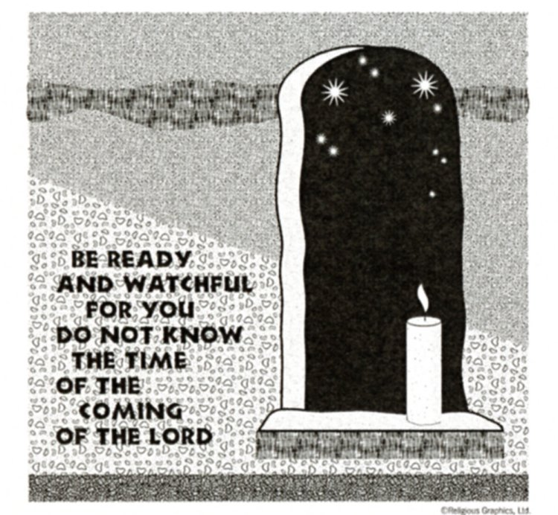

**SUNDAY MASS 10:00AM**

**SAT. VIGIL MASS 4:00PM**

**WEEKDAY MASS** **7:45AM**

**RECONCILIATION Saturday: 3:15 – 3:45PM**

**WEBPAGE:**  [www.strosechurchil.com](http://www.strosechurchil.com)

**EMAIL:** [belpsros@outlook.com](mailto:belpsros@outlook.com)

**FACEBOOK: St. Rose Catholic Church – St. Rose, IL**

**MASS WILL BE LIVE STREAMED ON OUR FACEBOOK PAGE SATURDAYS AT 4PM**

**SUNDAY COLLECTIONS:**

Thanksgiving: $40.00 Weekly Envelopes: $3,792.00

All Saints: $35.00 Sister Parish: $ 62.00

CCHD: $5.00 Capital Improvement Fund: $ 790.00

**MASS:** **INTENTIONS:**

Mon 7:45AM St. Rose Philippine Duchesne NO MASS

Tue 7:45AM Weekday NO MASS

Wed 7:45AM Weekday Jim Tebbe

Thu 7:45AM Presentation of the Blessed Virgin Mary NO MASS

Fri 7:45AM St. Cecilia Angie Foy

Sat 4:00PM Vigil: Our Lord Jesus Christ, King of the Universe For the Parish

Sun 10:00AM Our Lord Jesus Christ, King of the Universe Gene Buehne

“ “ “ “ “ “ Gerp Henrichs

“ “ “ “ “ “ Beth Timmermann Gross

**SERVERS:**

Sat Nov 23 4:00PM Isabella Goebel, Lexi Alberternst, Ava Sidwell, Ava Hilmes

Sun Nov 24 10:00AM Bria Tebbe, Zane Tebbe, Cole Timmermann, Alaina Timmermann

**READERS:** Sat Nov 23, 4:00PM Peggy Thole Sun Nov 24, 10:00AM Myrt Rollins

**EUCHARISTIC MINISTERS:**

Sat Nov 23, 4PM Jean Tebbe Sun Nov 24, 10AM Rich Koerkenmeier, Nic Wessel

**OFFERTORY:** Sat Nov 23, 4:00PM Rose Rensing, Rich Knebel, Mike Timmermann

Sun Nov 24, 10:00AM Buehne, Henrichs & Timmermann (Gross) Families

**VOCATION CUP**: The next person to receive the Vocation Cup is Pat Detmer.

**CYM MEETING: THIS** Sunday, Nov. 17th at 11AM. All HS students from the parish are welcome!

“HAVE YOU REMEMBERED ST. ROSE PARISH IN YOUR ESTATE PLANNING?”

**SYMPATHY:** Our sympathy to the family of Bishop James P. Keleher. Bishop Keleher was a former

Belleville Diocesan Bishop. He was 93 years old. May Bishop Keleher enjoy the reward of eternal life.

**SYMPATHY**: Our sympathy to the family of Mike Fix. Mike, who passed away recently, was the

brother of Peggy (Ron) Schrage. May Mike enjoy the reward of eternal life.

**ANNIVERSARIES:**

Nov 21 Dale & Amy Richter ’98 Nov 23 Rob & Rita Sidwell ’96 Nov 24 Richard & Norma Rothengass

Nov 24 Mark & Renee Steinmann ’01 Nov 25 Lavern & Eileen Thole ‘70

**BIRTHDAYS:**

Nov 18 Callie Buehne 7 Nov 20 Kammi Tebbe Nov 23 Patricia Detmer

Nov 18 Mike Kaufman Nov 20 Eugene Wilken Nov 23 Sadie Diekemper 9

Nov 18 Heather Rehkemper Nov 21 Donna Essig Nov 23 Emily Gall

Nov 18 Rose Rensing Nov 21 Shirley Henrichs Nov 23 Bryna Harrison 14

Nov 18 Courtney Taylor Nov 21 Kelli Poettker 11 Nov 23 Dylan Leyva 18

Nov 18 Tim Trame Nov 22 Alyssa Gall Nov 24 Connor Tebbe

Nov 19 Rebecca Boeschen Nov 22 Tara Smith Nov 24 Amy Tebbe

Nov 19 Maryn Heinzmann 4 Nov 22 Karen Tebbe

Nov 19 Karl Stock Nov 23 Ron Becker

**VOCATIONS CORNER:**

“My vocation to the Dominican Order and to the priesthood was carefully formed by God through the many people he placed in my life. First and most influential was my Syro-Malabar Catholic family, from whom I learned both the meaning of my faith and how to live it out. More than anyone else, my parents helped shape me as a man of faith and taught me to see everything in light of God’s providence. Everywhere I have lived – including in India, Calif., Missouri, Ohio and Alaska – friends, teachers, priests and others supported me and, most importantly, prayed for me. This constant stream of graces continues to sustain me through my formation as a Dominican friar. It is impossible to be a saint on one’s own. “

**THANKSGIVING DAY DINNER**:

At St. Henry’s Catholic Church Msgr. Voss Parish Center in Belleville from 10:45AM till noon on Thanksgiving Day. Call for reservations at 618-722-5024 before Nov. 20. No carry-outs,

**CATHOLIC CAMPAIGN FOR HUMAN DEVELOPMENT (CCHD):**

Please be generous in this week’s special collection for CCHD. This program supports programs that address the root causes of poverty across the country and in our diocese. Learn more about the

CCHD at diobelle.org/catholic-charities/cchd. Please be generous.

**HSHS ST. JOSEPH’S HOSPITAL QUILT RAFFLE:**

Twenty-five and and machine quilted quilts in a rainbow of collors & patterns will be featured on the “Keeping Us in Stitches” raffle sponsored by the Auxiliary at HSHS in Breese. Tickets are $25 each & only 400 tickets will be sold. Drawing is Dec 7th at the Auxiliary Holiday Party. Available in the

hospital gift shop or by contacting 618-526-5351 or [Christine.gebke@hshs.org](mailto:Christine.gebke@hshs.org).

Proceeds benefit the hospital or Auxiliary Scholarship Program.

**CHRISTMAS GIFTS FOR THE NEEDY:**

Once again we will be accepting Christmas gifts for the needy. Names will be in envelopes at

all entrances to church. PLEASE, return your gift no later than Sunday, December the 8th.