**ST. ROSE CHURCH**

**ST. ROSE, IIlinois**

**Fr. Edward F. Schaefer**

18010 St. Rose Road

526-4118 Rectory

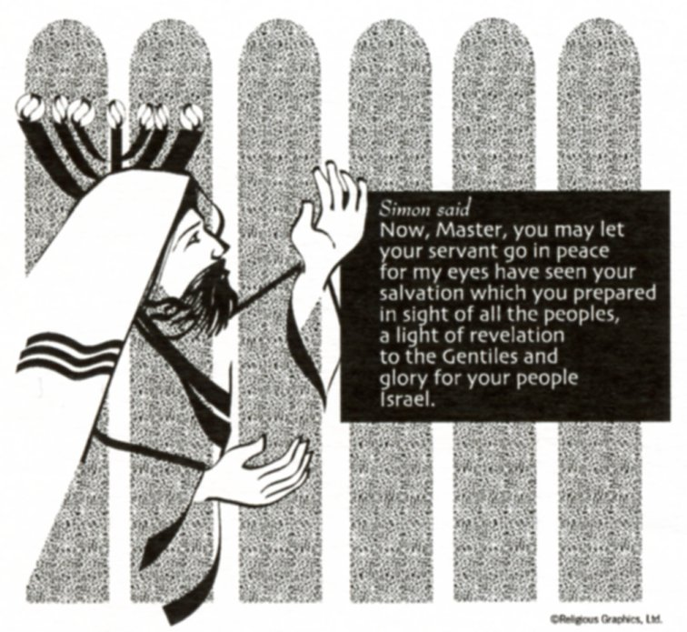

**SUNDAY MASS 10:00AM**

**SAT. VIGIL MASS 4:00PM**

**WEEKDAY MASS** **7:45AM**

**RECONCILIATION Saturday: 3:15 – 3:45PM**

**WEBPAGE:**  [www.strosechurchil.com](http://www.strosechurchil.com)

**EMAIL:** [belpsros@outlook.com](mailto:belpsros@outlook.com)

**FACEBOOK: St. Rose Catholic Church – St. Rose, IL**

**MASS WILL BE LIVE STREAMED ON OUR FACEBOOK PAGE SATURDAYS AT 4PM**

**SUNDAY COLLECTIONS:**

Weekly Envelopes: $ 3,422.00

Sister Parish: $ 70.00

Christmas: $100.00 Capital Improvement Fund: $ 1,944.00

**MASS** **INTENTIONS:**

Mon 7:45AM St. Blaise & St. Ansgar NO MASS

Tue 7:45AM Weekday NO MASS

Wed 7:45AM St. Agatha John Henrichs

**T**hu 7:45AM St. Paul miki & Companions NO MASS

Fri 7:45AM Weekday John & Bea Tebbe

Sat 4:00PM Vigil: Fifth Sunday in Ordinary Time William & Floriann Timmermann

“ “ “ “ Mary Ann Hempen

“ “ “ “ Gerp Henrichs

Sun 10:00AM: Fifth Sunday in Ordinary Time For the Parish

**SERVERS:**

Sat Feb 8 4:00PM Ava Sidwell, Seth Lane, Ali Butler, Lane Butler

Sun Feb 9 10:00AM Elsie Thole, Tinsley Schwierjohn, Wade Kramer, Briggs Kramer

**READERS:** Sat Feb 8 4:00PM Peggy Thole Sun Feb 9 10:00AM Lisa Baer

**EUCHARISTIC MINISTERS:**

Sat Feb 8 4:00PM Karla Tebbe Sun Feb 9 10:00AM John & Kate Kohlbrecher

**OFFERTORY:**

Sat Feb 8 4:00PM Timmermann, Hempen & Henrichs Families

Sun Feb 9 10:00AM Gary Vonder Haar, Stan Essenpreis, Mike Timmermann

**VOCATION CUP**: The next person to receive the Vocation Cup is the Bryan Eversgerd Family.

**CONGRATULATIONS:** To: Lorelai Marie Jacob who was Baptized here last weekend. Lorelai, is the

daughter of Kyle and Evonne (Huelsmann) Jacob. Many Blessings to her!

**CONGRATULATIONS:** To Lily Jean Beer who was Baptized here last weekend. Lily, is the daughter of

Cameron & Larissa (Jacob) Beer. Many Blessings to her!

**CONGRATULATIONS**: To Dee Boeing who is listed on the Southern Illinois University, Carbondale 2024 Fall Dean’s List and Graduation List and the Kaskaskia College Honor Roll.

**CONGRATULATIONS**: To the following Kaskaskia College Honor Roll Students:

Jayce Robke, Jaydon Tebbe, Dane Thole, Elizabeth Snyder, Nadia Baer, Mabry Benhoff, Ella Detmer,

Grayce Henrichs, Lily Ann Goebel and Rylie Kluemke.

**CONGRATULATIONS:** To Mabry Benhoff who was named Central High School Student of the Week.

**ANNIVERSARIES**: Feb 4 Dan & Cheryl Koerkenmeier ’95 Feb 4 Dan & Tiffany Wilke ‘23

Feb 5 Daniel & Angela Diekmann ’94 Feb 9 Cody & Karlie Tebbe ‘19

**BIRTHDAY:** Happy Belated Birthday to Dolores Henrichs who had a Birthday on January 23rd and was

accidentally omitted from last week’s bulletin.

**BIRTHDAYS:**

Feb 3 Justin Dulle Feb 5 Michelle Buehne Feb 8 Terri Jansen

Feb 3 Macy Tebbe 10 Feb 5 Harlin Kramer 9 Feb 8 Joanne Rehkemper

Feb 3 Doris Timmermann Feb 7 Blake Benhoff Feb 9 Peter Boeing

Feb 4 Betty Eilers Feb 7 Allen Schrage Feb 9 April Brinker

Feb 4 Michael Harper Feb 7 Katherine Thole Feb 9 Paityn Fuhler 11

Feb 4 Greg Rehkemper Feb 8 Marlene Holtgrave

**VOCATIONS CORNER:**

In 1997, Pope St. John Paul II instituted a day of prayer for women and men in consecrated life.

This celebration is attached to the Feast of the Presentation of the Lord on Feb 2nd. (Candlemass Day).

Let us make it a point to begin saying “THANK YOU” to our Sisters and Brothers who have made

sacrifices for us by accepting God’s call. Let them know how important they are in the life of your

church and how they help you to honor and pray to our Lord and Savior, Jesus Christ.

**ST. VINCENT DE PAUL COAT COLLECTION:** So far, 105 coats have been collected.

Thank you for your generosity!

**ST. ROSE YOUTH LEAGUE UPDATE:**

Thanks to all who made the breakfast a success! Baseball, Softball & T-Ball registration is open from

Feb 1 through Feb 21. Last call for the St. Rose Discount Cards $20. If you have any questions about

registration or the discount cards contact Eric Benhoff 618-604-8917.

**ST. AUGUSTINE PARISH TRIVIA NIGHT:**

Saturday, Feb 1st at 6:30PM in the Breese Knights of Columbus Hall. Doors open at 6PM.

$100 per team (8) players). $15 for an individual. For more information or to register call Donny

Petterson at 618-210-7099.

**VALENTINE’S DAY DINNER:**

St. Ann’s Nashville on Sat Feb 8th. See bulletin board for more info or call 618-722-5037.

**CFL EUCHRE TOURNAMENT**:

Sunday, Feb. 9th in the Development Club at 1PM. Proceeds benefit the St. Rose PSR Program.

**CARLYLE KNIGHTS OF COLUMBUS ANNUAL BASKET BINGO:**

Sunday, Feb 9th at the Carlyle KC Hall. Doors open at 11AM and Bingo starts at 1PM.

**KING’S HOUSE AT THE SHRINE OF OUR LADY OF THE SNOWS DAY OF REFLECTION**:

“The Mirror of Consciousness: Seeing the Divine in all things” presented by Paul Coutinho, PhD on

Wed, Feb 12th from 9AM to 3PM at the Visitors Center. Cost is $60 and includes lunch.

To register or for more information call 618-397-0584 or go on line to https://kh.snows.org/events/coutinho2025.

**TEENS ENCOUNTER CHRIST #273 (TEC:**

Saturday – Monday, Feb 15-17, 2025 at St.Mary Parish, Mount Vernon.

If interested, contact Mary Frances at 618-973-9828 or <http://www.bellevilletec.org>, or see the

bulletin board.

“HAVE YOU REMEMBERED ST. ROSE PARISH IN YOUR ESTATE PLANNING?”