**ST. ROSE CHURCH**

**ST. ROSE, IIlinois**

**Fr. Edward F. Schaefer**

18010 St. Rose Road

526-4118 Rectory

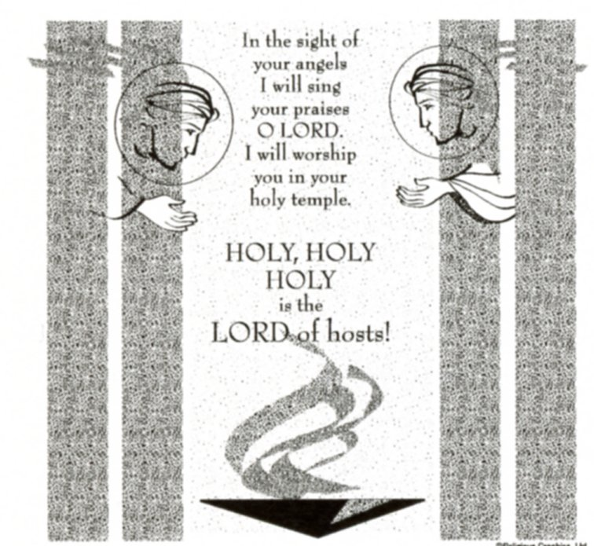

**SUNDAY MASS 10:00AM**

**SAT. VIGIL MASS 4:00PM**

**WEEKDAY MASS** **7:45AM**

**RECONCILIATION Saturday: 3:15 – 3:45PM**

**WEBPAGE:**  [www.strosechurchil.com](http://www.strosechurchil.com)

**EMAIL:** [belpsros@outlook.com](mailto:belpsros@outlook.com)

**FACEBOOK: St. Rose Catholic Church – St. Rose, IL**

**MASS WILL BE LIVE STREAMED ON OUR FACEBOOK PAGE SATURDAYS AT 4PM**

**SUNDAY COLLECTIONS:**

Weekly Envelopes: $ 4,413..00

Sister Parish: $ 30.00

Capital Improvement Fund: $ 885.00

**MASS** **INTENTIONS:**

Mon 7:45AM St. Scholastica NO MASS

Tue 7:45AM Our Lady of Lourdes NO MASS

Wed 7:45AM Weekday Jeanette Benhoff

**T**hu 7:45AM Weekday NO MASS

Fri 7:45AM Sts. Cyril, Monk & Methodus Marie Straeter

Sat 4:00PM Vigil: Sixth Sunday in Ordinary Time For the Parish

Sun 10:00AM: Sixth Sunday in Ordinary Time Tom, Judy & Sue Ann Wilke

“ “ “ “ Gervase Henrichs

“ “ “ “ Gerald Wellen

**SERVERS:**

Sat Feb 15 4:00PM Paityn Fuhler, Lane Tebbe, Theodore Tebbe, Lexi Alberternst

Sun Feb 16 10:00AM Lauryn Vonder Haar, Aubrey Thole, Mandy Poettker, Kelli Poettker

**READERS:** Sat Feb 15 4:00PM Don Henrichs Sun Feb 16 10:00AM Kayden Barriger

**EUCHARISTIC MINISTERS:**

Sat Feb 15 4:00PM Tom Harper Sun Feb 16 10:00AM Bev Kapp & Rose Rensing

**OFFERTORY:**

Sat Feb 15 4:00PM Don Tebbe, John Hustedde, Gervase Klostermann

Sun Feb 16 10:00AM Wilke, Henrichs & Wellen Families

**VOCATION CUP**: The next person to receive the Vocation Cup is the Edward Faust Family.

**PARISH COUNCIL POSITIONS NEEDED:**

If interested in joining the Parish Council, please contact the office, Fr. Ed or a council member.

**WELCOME**:

Please welcome Bishop Michael McGovern who is having the 4PM Mass on Saturday & Fr. Pat Jakel who is having the 10AM Mass on Sunday this weekend. Thank you !!

**SYMPATHY:** Our sympathy to the family of Robert Robke who passed away recently. Robert was

the grandfather of Calvin (Erin) Robke and Ivy Robke. May Robert enjoy the reward of eternal life.

**CONGRATULATIONS**: Ty Kueper and Avery Rahden who were placed on the Greenville University Dean’s List for the Fall 2024 Semester.

**CONGRATULATIONS:** To the following Central High School students who were listed on the First Semester Honor Roll: Gavin Cook, Austin Hilmes, Hailey Kohlbrecher & Blake Monken.

**BIRTHDAYS:**

Feb 10 Jay Detmer Feb 12 Barbara Rinderer Feb 15 Joe Schwierjohn

Feb 10 Galynn Gertsch Feb 12 Mark Tebbe Feb 15 Ava Sidwell

Feb 10 Marie Henrichs Feb 13 Sean Alberternst Feb 16 Mabry Benhoff 17

Feb 11 Ryan Emig Feb 13 Pat Vander Haar Feb 16 Brett Huelsmann

Feb 11 Cole Kapp 19 Feb 15 Addison Hilmes 16 Feb 16 Deb Knebel

Feb 12 Dave Boeschen Feb 15 Rylie Kluemke 19 Feb 16 Ethan Schumacher

Feb 12 Mandy Poettker 13 Feb 15 Rhonda Schulte Feb 16 Scarlett Tehandon 7

**ST. ROSE SCHOOL:**

NO SCHOOL Fri Feb, 14th Teacher Institute Day and NO SCHOOL Mon Feb. 17th Presidents Day

**MATER DAY:**

Mother’s & Friends Meeting Feb. 10th at 7PM NO SCHOOL Fri. Feb. 14th – County Institute Day

**CENTRAL HIGH SCHOOL:** NO SCHOOL Fri. Feb 14th and Mon. Feb. 17th.

**VOCATIONS CORNER:**

A sage once wrote that a good marriage is like a fire around which others come to warm themselves.

So, as we celebrate **World Marriage Day** on this Sunday, we realize that not matter our station in life –

married, single or religious – we have benefited from this sacred covenant relationship whether

through the example of our parents, grandparents, and other role models or through our own

stewardship of the marriage covenant. For the Catholic steward, marriage goes far beyond the legal

or societal agreement that our culture might define. Marriage brings us countless blessings but is met

with many obstacles. Busy schedules, the challenges of parenthood, the strains of fiances, mortgages,

issues of health and aging – all of these test the bonds of even the finest unions.

**ST. MARY, CARLYLE ANNUAL BLANKET BINGO:**

Sunday, Feb 9th at the Carlyle KC Hall. Doors open at 11AM, Bingo starts at 1PM.

**ST. ROSE YOUTH LEAGUE UPDATE:**

Thanks to all who made the breakfast a success! Baseball, Softball & T-Ball registration is open from

Feb 1 through Feb 21. Last call for the St. Rose Discount Cards $20. If you have any questions about

registration or the discount cards contact Eric Benhoff 618-604-8917.

**CFL EUCHRE TOURNAMENT**:

THIS Sunday, Feb. 9th in the Development Club at 1PM. Proceeds benefit the St. Rose PSR Program.

**HEARTLAND COMMUNITY CHORUS QUILT RAFFLE:**

Next weekend, Feb. 15th & 16th tickets for the Quilt Raffle will be sold in the back of church after the weekend Masses. Quilt will be on display.

**TEENS ENCOUNTER CHRIST #273 (TEC:**

Saturday – Monday, Feb 15-17, 2025 at St.Mary Parish, Mount Vernon.

If interested, contact Mary Frances at 618-973-9828 or <http://www.bellevilletec.org>, or see the

bulletin board.

**MATER DEI KNIGHTS AT THE RACES:**

Saturday, Feb 15th from 6PM to 11PM. Tickets $50 each which includes appetizers, open bar, funny money for wagering & chances to win prizes. Additional details and reservations at [www.materdeiknights.org(“Announcement”)](http://www.materdeiknights.org() section. Tickets sold at the door but reservations preferred.

“HAVE YOU REMEMBERED ST. ROSE PARISH IN YOUR ESTATE PLANNING?”