**ST. ROSE CHURCH**

**ST. ROSE, IIlinois**

**Fr. Edward F. Schaefer**

18010 St. Rose Road

526-4118 Rectory

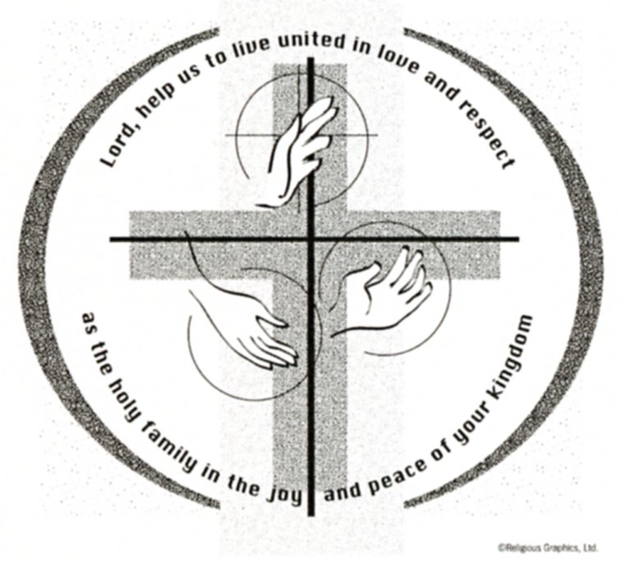

**SUNDAY MASS 10:00AM**

**SAT. VIGIL MASS 4:00PM**

**WEEKDAY MASS** **7:45AM**

**RECONCILIATION Saturday: 3:15 – 3:45PM**

**WEBPAGE:**  [www.strosechurchil.com](http://www.strosechurchil.com)

**EMAIL:** [belpsros@outlook.com](mailto:belpsros@outlook.com)

**FACEBOOK: St. Rose Catholic Church – St. Rose, IL**

**MASS WILL BE LIVE STREAMED ON OUR FACEBOOK PAGE SATURDAYS AT 4PM**

**SUNDAY COLLECTIONS:**

Weekly Envelopes: $ 3,759.00

Christmas: $12,495.00 Sister Parish: $ 465.00

Capital Improvement Fund: $ 1,760.00

Immaculate Conception $20.00 Religious Retirement: $ 70.00

Christmas for the Needy $1,173.00

**MASS:** **INTENTIONS:**

Mon 7:45AM 6th Day within the Octave of the Nativity NO MASS

**Tue 4:00PM VIGIL: 7th Day within the Octave of the Nativity** Rem & Joseph Grapperhaus

**Wed 9:00AM The Octave Day of the Nativity & Solemnity of Mary** Marie Straeter

Thu7:45AM St. Basil the Great & St. Gregory Nazianzen NO MASS

Fri 7:45AM Holy Name of Jesus Mary Ann Hempen

Sat 4:00PM Vigil: The Epiiphany of The Lord Paul & Jeanette Rehkemper

“ “ “ “ Jim Tebbe

“ “ “ “ Ferd H, Tebbe

Sun 10:00AM The Epiphany of The Lord For the Parish

**SERVERS:**

Tue Dec 31 4:00PM **Volunteers Needed**

Wed Jan 01 9:00AM Mandy Poettker, Kelli Poettker, **2 Volunteers Needed**

Sat Jan 04 4:00PM Paityn Fuhler, Ali Butler, Lane Butler, Lennon Emig

Sun Jan 05 10:00AM Wyatt Stock, Alaina Schrage, Ruby Jansen, Brady Jansen

**READERS:** Tue Dec 31 4:00PM Mike Schumacher Wed Jan 01 9:00AM Mary Lou Voss

Sat Jan 04 4:00AM Brenda Niedzwiecki Sun Jan 06 10:00AM Lisa Baer

**EUCHARISTIC MINISTERS:**

Tue Dec 31 4:00PM Marilyn Fuhler & Melanie Rund

Wed Jan 01 9:00AM Jesse Thole & Jean Tebbe

Sat Jan 04 4:00PM Betsy Buehne & John Hustedde

Sun Jan 05 10AM Tom Harper & Linda Habermehl

**OFFERTORY:**

Tue Dec 31 4:00PM Grapperhaus Family & Brent Timmermann

Wed Jan 01 9:00AM Straeter Family & Nick Timmermann, Jr.

Sat Jan 04 4:00PM Rehkemper, & Tebbe Families

Sun Jan 05 10:00AM Bill Timmermann, Dave Brinker, Cory Schneider

**VOCATION CUP**: The next family to receive the Vocation Cup is the Ed Eilers Family .

**ANNIVERSARIES**: Dec 31 Cameron & Larissa Beer ‘22

Jan 02 John & Pamela Andrews ‘71

**BIRTHDAYS:**

Dec 30 Kenadi Barriger Dec 31 Alicia Eversgerd Jan 3 Lennon Huelsmann 6

Dec 30 Tom Harper !! Dec 31 Reagan Lohman 4 Jan 3 Isabella Tehandon 3

Dec 30 Lillian Hilmes 11 Jan 01 Luke Fuhler Jan 3 Cora Wiegmann 11

Dec 30 Adam Kampwerth Jan 01 Patricia Poettker Jan 4 Kristi Poettker

Dec 30 Beth Meier Jan 01 Brianna Timmermann Jan 4 Eric Poettker

Dec 30 Dennis Schumacher Jan 02 Amy Kampwerth Jan 4 Carl Rosen

Dec 30 Briana Tebbe Jan 03 Kayla Barth Jan 4 Brinley Schrage 8

Dec 30 Sandra Timmermann Jan 03 Peyton Becker

Dec 30 Elaine Voss Jan 03 Logan Goebel

**VOCATIONS CORNER:**

- Today we celebrate the Holy Family of Jesus, Mary, and Joseph. Each of them was called to in a unique way to love and serve their family, but the power of their love within also *went out* to the world. The Gospel story tells of Jesus being presented in the temple as per the law. They are already “sharing” their Son with the world as acknowledged by Simeon and Anna. Can we, as family, support one of our family members who might be discerning a call to the religious life? Joseph and Mary made that ultimate sacrifice. .

**ST. VINCENT DE PAUL NEEDS COATS:**

Gently used or new coats of all types in all sizes for all ages – toddlers, children, teens & adults

(men and women) are being requested**. Items can be dropped off in the baby crib at the front of church.**

“HAVE YOU REMEMBERED ST. ROSE PARISH IN YOUR ESTATE PLANNING?”

**HAVE** **A SAFE AND BLESSED NEW YEAR!**