**ST. ROSE CHURCH**

**ST. ROSE, IIlinois**

**Fr. Edward F. Schaefer**

18010 St. Rose Road

526-4118 Rectory

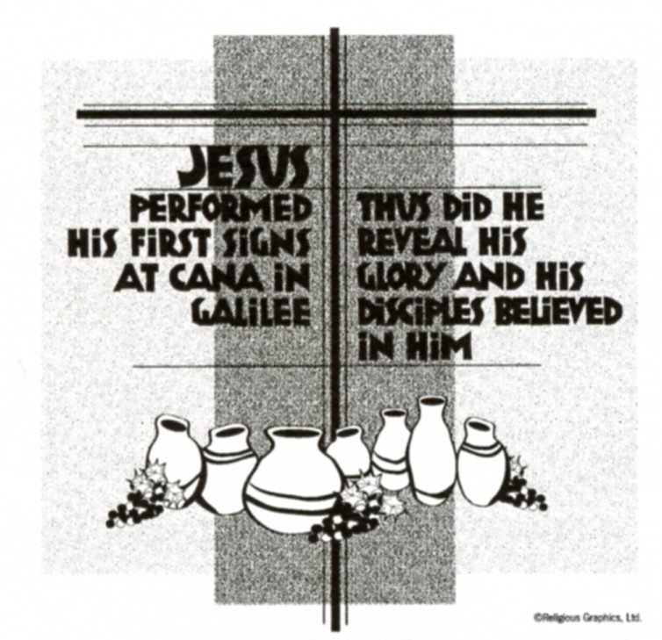

**SUNDAY MASS 10:00AM**

**SAT. VIGIL MASS 4:00PM**

**WEEKDAY MASS** **7:45AM**

**RECONCILIATION Saturday: 3:15 – 3:45PM**

**WEBPAGE:**  [www.strosechurchil.com](http://www.strosechurchil.com)

**EMAIL:** [belpsros@outlook.com](mailto:belpsros@outlook.com)

**FACEBOOK: St. Rose Catholic Church – St. Rose, IL**

**MASS WILL BE LIVE STREAMED ON OUR FACEBOOK PAGE SATURDAYS AT 4PM**

**SUNDAY COLLECTIONS:**

Weekly Envelopes: $ 2,324.00

Sister Parish: $ 115.00

Donations: $3.850.00 Capital Improvement Fund: $ 205.00

**MASS** **INTENTIONS:**

Mon 7:45AM St. Angela Merici NO MASS

Tue 7:45AM St. Thomas Aquinas NO MASS

Wed 7:45AM Weekday Elvira (Toots) Tebbe

**T**hu 7:45AM Weekday NO MASS

Fri 7:45AM St. John Bosco Marie Straeter

Sat 4:00PM Vigil: Presentation of The Lord L/D Theodore & Agnes Henrichs Family

“ “ “ “ JoAnn VonderHaar

“ “ “ “ Paul & Jeanette Benhoff

Sun 10:00AM: Presentation of The Lord For the Parish

**SERVERS:**

Sat Feb 1 4:00PM Alaina Schrage, Gavin Schneider, Rylan Schneider, Theodore Tebbe

Sun Feb 2 10:00AM Wyatt Stock, Senya Rahden, Eli Henrichs, Lauryn Vonder Haar

**READERS:** Sat Feb 2 4:00PM Mary Lou Voss Sun Feb 2 10:00AM Myrt Rollins

**EUCHARISTIC MINISTERS:**

Sat Feb 1 4:00PM John Hustedde

Sun Feb 2 10:00AM Deb Wilke, Matt W. Benhoff

**OFFERTORY:**

Sat Feb 1 4:00PM Henrichs, Vonder Haar & Benhoff Families

Sun Feb 2 10:00AM John Kohlbrecher, Leon Langenhorst, David Thole

**VOCATION CUP**: The next person to receive the Vocation Cup is the Stanley Essenpreis Family.

**CONGRATULATIONS:** To.

**CONGRATULATIONS:** To Frr Boeing who was among the Fall 2024 Southern Illinois University Carbondale Fall 2024 graduates.

**CONGRATULATIONS**: To the following Mater Dei students who were listed on the Honor Roll for the

second quarter & first semester of this academic year: Rylee Alberternst, Nadia Baer, Addison Hilmes,

Alyssa Koerkenmeier, William Meyer, Bella Thole, Caitlyn Vonder Haar, Lily Goebel, Claire Thole

and Lydia Thole.

**CONGRATULATIONS**: To the following Central HS students who were listed on the Honor Roll for the

second quarter: Kayley Burian, Ella Henrichs, Danica Henrichs, Marissa Jansen, Grayce Sturgeon,

Landon Tebbe, Addison Thole, Lukas Winkeler, Peyton Markus, Rylan Segert, Addison Tebbe, Loralei

Schwierjoh, Elizabeth Snyder, Grace Henrichs, Jacey Robke, Lily Butler, Emily Cirrincione, Madeline

Fuhler, Brooke Harrison, Lillian Henrichs, Morgan Kapp, Paige Kapp, Reed Segert, Rebecca Sturgeon,

Laney Tebbe, Romayne Tebbe and Luke Thole.

**CONGRATULATIONS:** To Andrea (Voss) Toennies who was inducted into the Southern Illinois

University Edwardsville Athletic Hall of Fame.

**SYMPATHY:** Our sympathy to the family of Deborah (Deb) Rakers. Deb, who passed away recently,

was the Assistant Administrator at St. Felicitas Parish, Beaver Prairie. May Deb enjoy the rward of eternal life..

**ANNIVERSARIES**: Jan 27 Ron & Debra Tebbe ’79 Feb 2 John & Jan Kalmer ‘74

**BIRTHDAYS:**

Jan 27 Brittany Fuhler Jan 29 Deborah Wilke Feb 01 Lorene Rehkemper

Jan 27 Christopher Thole Jan 30 Marilyn Bruggemann Feb 01 Marilyn Schorfheide

Jan 27 Gerald Thole Jan 30 Wesley Buehne Feb 02 Lainey Clugston 6

Jan 28 Cora Emig 2 Jan 30 Ronald Holtgrave Feb 02 Brady Jansen 11

Jan 28 Kennedy Emig 2 Jan 30 Vincent Tebbe Feb 02 Sherry Rehkemper

Jan 28 Joan Goebel Jan 30 Edward Wilke Feb 02 Brandy Schwierjohn

Jan 28 Mitchell Segert Jan 31 Omar Rojas, Jr. 17 Feb 02 Andrew Tebbe

Jan 28 Madilyn Sussen 5 Jan 31 Pat Wellen

Jan 28 Carrie Kramer Feb 01 Dave Kueper

**VOCATIONS CORNER:**

My parents gave me and my siblings a joyful and loving childhood where the beauty of the Catholic faith shone brightly. They sent us to a school in Madrid operated by the sisters of the Company of the Savior, whose charism is to cooperate with parents by providing a strong education in a faithful catholic environment. The joy, devotion and dedication of the sisters immediately attracted me. During my last years of high school and my first year of college, I was tempted by new experiences and friendships based on different ideals than those of my youth. It was Mary who opened my eyes to see deeper. She brought me back to the heart of Jesus. Eventually, I embraced His loving call to be only his and joined the Sisters of the Company of the Savior.

*Sr. Maria Alguacil; Sisters of the Company of the Savior; Columbia*

**PARISH COUNCIL MEETING:**

Tuesday, January 28th at 7PM in the Conference Room at the school.

**ST. AUGUSTINE PARISH TRIVIA NIGHT:**

Saturday, Feb 1st at 6:30PM in the Breese Knights of Columbus Hall. Doors open at 6PM.

$100 per team (8) players) of $15 for an individual. For more information or to register call Donny

Petterson at 618-210-7099.

**CFL EUCHRE TOURNAMENT**:

Sunday, Feb. 9th in the Development Club at 1PM. Proceeds donated to the St. Rose PSR Program.

“HAVE YOU REMEMBERED ST. ROSE PARISH IN YOUR ESTATE PLANNING?”