**ST. ROSE CHURCH**

**ST. ROSE, IIlinois**

**Fr. Edward F. Schaefer**

18010 St. Rose Road

526-4118 Rectory

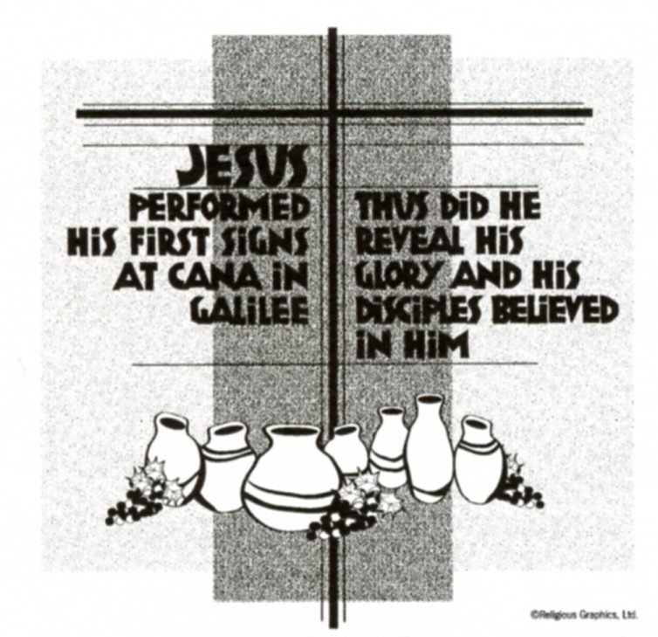

**SUNDAY MASS 10:00AM**

**SAT. VIGIL MASS 4:00PM**

**WEEKDAY MASS** **7:45AM**

**RECONCILIATION Saturday: 3:15 – 3:45PM**

**WEBPAGE:**  [www.strosechurchil.com](http://www.strosechurchil.com)

**EMAIL:** [belpsros@outlook.com](mailto:belpsros@outlook.com)

**FACEBOOK: St. Rose Catholic Church – St. Rose, IL**

**MASS WILL BE LIVE STREAMED ON OUR FACEBOOK PAGE SATURDAYS AT 4PM**

**SUNDAY COLLECTIONS:**

Weekly Envelopes: $ 2,052.00

Sister Parish: $ 72.00

Solemnity of Mary: $30.00 Capital Improvement Fund: $ 480.00

**MASS** **INTENTIONS:**

Mon 7:45AM St. Fabian & St, Sebastian NO MASS

Tue 7:45AM St. Agnes NO MASS

Wed 7:45AM Day of Prayer for the Legal Protection of Unborn Children Anna Mae Frisse

**T**hu 7:45AM St. Vincent & St. Marianne Cope NO MASS

Fri 7:45AM St. Francis de Sales Terry Kampwerth

Sat 4:00PM Vigil: Third Sunday in Ordinary Time Jim Tebbe

“ “ “ “ JoAnn Vonder Haar

“ “ “ “ Edwina Tebbe

Sun 10:00AM Third Sunday in Ordinary Time For the Parish

**SERVERS:**

Sat Jan 25 4:00PM Everett Jansen, Asher Jansen, William Timmermann, Lane Tebbe

Sun Jan 26 10:00AM Lillian Hilmes, Cole Timmermann, Alaina Timmermann, Aubrey Thole

**READERS:** Sat Jan 25 4:00AM Jeff Kampwerth Sun Jan 26 10:00AM Pam Andrews

**EUCHARISTIC MINISTERS:**

Sat Jan 25 4:00PM Betsy Buehne

Sun Jan 26 10:00AM Avoynna Kampwerth & Julie Bruggemann

**OFFERTORY:**

Sat Jan 25 4:00PM Tebbe & Vonder Haar Families

Sun Jan 26 10:00AM David Buehne, Mark Faust, Mike Detmer

**VOCATION CUP**: The next person to receive the Vocation Cup is the David ErlingerFamily.

**CONGRATULATIONS:** To Joseph Cirrincione who was named to the University of Southern Indiana Dean’s List for the 2024 Fall Semester.

**CONGRATULATIONS:** To the following December St. Rose Wildcats of the month:

Jocelyn Fuhler, Phoenix Tucker, Rylan Schneider and Tinsley Schwierjohn.

**SYMPATHY:** Our sympathy to the family of Gerald “Short” Tebbe. Short who passed away

recently, was the brother of Mike (Rita) Tebbe and Chuck (Jackie) Tebbe. May Short enjoy the

reward of eternal life.

**SYMPATHY:** Our sympathy to the family of Elmer Loepker. Elmer, who passed away recently,

was the brother of Marilyn (David) Buehne. May Elmer enjoy the reward of eternal life.

**ANNIVERSARIES**: Jan 22 Cory & Kim Schneider ‘11

**BIRTHDAYS:**

Jan 20 Emily Gnaedinger Jan 21 Daniel Trame Jan 25 Scott Kuhn

Jan 20 Blake Remmert Jan 23 Jackie Fuhler Jan 25 Bently Williams

Jan 20 Cassidy Ribbing 7 Jan 23 Paul Meyer Jan 26 Derek Frey

Jan 21 Karlie Rakers 5 Jan 23 Paul Meyer Jan 26 Cassy Rakers

Jan 21 Christopher Rojas 20 Jan 24 Richelle Bohnert Jan 26 Nancy Rehkemper

Jan 21 Ronald Schrage Jan 24 Sadie Schumacher 1 Jan 26 Landon Tebbe 14

Jan 21 Virgil Tebbe Jan 25 David Knebel 5 Jan 26 Diane Thole

**VOCATIONS CORNER:**

Today we hear the famous story of the Wedding Feast at Cana. Jesus is celebrating with the happy couple – a salute to the vocation of marriage. And He honors His mother’s request to intervene as the wine runs out. We are now issued the one of the greatest calls to holiness of the ages – “Do whatever He tells you.” As this was the “beginning of his signs…and so revealed his glory”, are we seeing his signs and doing whatever he tells us? Are we called to something greater?

**ST. ROSE YOUTH LEAGUE BREAKFAST:**

Sausage & Pancake Breakfast, THIS Sunday, Jan 19th from 7:30AM to 11:30AM at St. Rose Park.

Drive-thru. Adults $14 and Children $7. Proceeds will benefit St. Rose Youth League activities.

**HEALING MASS CANCELLED:**

The Healing Mass scheduled at St. Ann’s in Nashville on Tuesday, Jan. 21st has been cancelled.

**KNIGHTS OF COLUMBUS 4TH DEGREE MEETING:**

Tuesday, Jan 21st at St. Mary Parish Center in Trenton IL at 7:30PM

**GODSPELL 2012**

Opens Thursday, Jan 23rd and runs through Sunday Feb 2 at the Lookingglass Playhouse in

Lebanon. Directed by Deacon Glenn Netemeyer. Godspell is a Musical about the Gospel of Matthew.

**BREESE KC PRO-LIFE LAPEL ROSES:**

Knights of Columbus Council 2869 will offer Pro-Life Lapel roses for a donation after the weekend masses on Jan 25th & 26th. Donations are used to support state and national Pro-Life activities and

local pregnancy care centers. Your generous support helps to defend Life!

**77TH ANNUAL SALEM UNITED CHURCH OF CHRIST SAUSAGE SUPER:**

Saturday, Jan 25th from 1PM to 7PM. 1117 West North St. in **Alhambra** IL. Drive thru available or seating in the Upper Parish Hall. Pre orders for meat also available at [salemuccmeatsales@agtelco.com](mailto:salemuccmeatsales@agtelco.com) or call 618-488-3216.

**ST. VINCENT DE PAUL COAT COLLECTION:**

To date a total of 78 coats have been donated to St. Vincent de Paul Coat drive. The Crib in church

will be left up to receive donations till the end of January. Thank you to all who have donated!

“HAVE YOU REMEMBERED ST. ROSE PARISH IN YOUR ESTATE PLANNING?”