**ST. ROSE CHURCH**

**ST. ROSE, IIlinois**

**Fr. Edward F. Schaefer**

18010 St. Rose Road

526-4118 Rectory

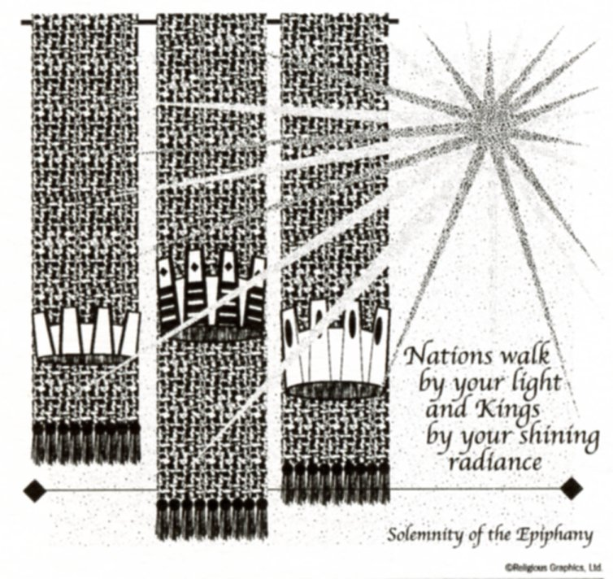

**SUNDAY MASS 10:00AM**

**SAT. VIGIL MASS 4:00PM**

**WEEKDAY MASS** **7:45AM**

**RECONCILIATION Saturday: 3:15 – 3:45PM**

**WEBPAGE:**  [www.strosechurchil.com](http://www.strosechurchil.com)

**EMAIL:** [belpsros@outlook.com](mailto:belpsros@outlook.com)

**FACEBOOK: St. Rose Catholic Church – St. Rose, IL**

**MASS WILL BE LIVE STREAMED ON OUR FACEBOOK PAGE SATURDAYS AT 4PM**

**SUNDAY COLLECTIONS:**

Weekly Envelopes: $ 3,320.00

Christmas: $882.00 Sister Parish: $ 20.00

Capital Improvement Fund: $ 320.00

Christmas for the Needy: $ 240.00

**MASS:** **INTENTIONS:**

Mon 7:45AM St. Andre Bessette NO MASS

Tue 7:45AM St. Raymond of Penyafort NO MASS

Wed 7:45AM Christmas Weekday MO MASS

Thu7:45AM Christmas Weekday NO MASS

Fri 7:45AM Christmas Weekday NO MASS

Sat 4:00PM Vigil: The Baptism of The Lord L/D Frank & Elsie Thole Family

“ “ “ “ Emma Musenbrock

“ “ “ “ Tony Musenbrock

Sun 10:00AM The Baptism of The Lord For the Parish

**SERVERS:**

Sat Jan 11 4:00PM Ava Sidwell, Gavin Schneider, Rylan Schneider, Seth Lane

Sun Jan 12 10:00AM Elsie Thole, Tinsley Schwierjohn, Wade Kramer, Briggs Kramer

**READERS:** Sat Jan 11 4:00AM Peggy Thole Sun Jan 12 10:00AM Mabry Benhoff

**EUCHARISTIC MINISTERS:**

Sat Jan 11 4:00PM Deb Wilke

Sun Jan 12 10:00AM Jean Tebbe & Pat Henrichs

**OFFERTORY:**

Sat Jan 11 4:00PM Thole & Musenbrock Families

Sun Jan 12 10:00AM Rich Knebel, Don Tebbe, Ralph Tebbe

**VOCATION CUP**: The next person to receive the Vocation Cup is Elizabeth Eilers.

**SYMPATHY**: Our sympathy to the family of Robert “Bob” Kampwerth who recently passed away.

Bob was the brother-in-law of Anna Jean Kampwerth. May Bob enjoy the reward of eternal life.

**SYMPATHY**: Our sympathy to the family of Norma Jansen who passed away recently. Norma was

sister of Jane Fuhler and Theodore “Butch” (Delores) Richter. May Norma enjoy the reward of eternal life.

**CONGRATULATIONS:** To Alyssa Koerkenmeier who was recognized as an Illinois State Scholar.

**ANNIVERSARIES**: Jan 06 Craig & Cassandra Benhoff ’18 Jan 07 Corey & Tina Hilmes ‘06

Jan 07 Kasey & Kelly Santel ’17 Jan 10 Brett & Jo Lynn Huelsmann ‘15

Jan 12 Ronald & Carol Kohlbrecher ‘91

**BIRTHDAYS:**

Jan 06 Carol Petermeyer Jan 07 Kelly Klostermann Jan 11 Marilyn Fuhler

Kam 06 Ava Tisher 14 Jan 08 Abigail Tebbe Jan 11 Pat Rollins

Jan 06 Mary Ann Trame Jan 09 Peyton Markus 15 Jan 11 Alan Schorfheide

Jan 07 Pamela Andrews Jan 10 Steven Kaufman 21 Jan 12 Blair Remmert 3

Jan 07 Kayley Burian 14 Jan 10 Kathryn Timmermann

**VOCATIONS CORNER:**

What a wonderful Gospel account of the Magi traveling to meet the Lord. They followed the star – their “call” – to come and offer their gifts to the Lord. But the question arises as to how the Magi noticed a star at night and no one else really did. Perhaps we need to embrace the “night”, the stillness, to “see and hear” our call. How are we doing in discerning our call to Holiness – in living our vocation as man, woman or child; married or single; priesthood or religious – of being called to something beyond ourselves?

**ATTENTION LADIES:**

We plan to start quilting in January on Tuesdays & Thursdays from 12:30 to 4:30PM.

The first date will be on Jan 14th in the quilting room in the convent. Anyone who would like to bring a dessert and visit would be welcomed. Thank you Melanie 618-570-7357.

**NATIONWIDE PRAYER VIGIL FOR LIFE:**

Friday, Jan 24th from 8AM to 8PM at St. Teresa Catholic Church in Belleville and Eucharistic Adoration from 6:30PM to 7:30PM at St. Boniface Catholic Church in Germantown.

See bulletin board for more information or contact mking!diobelle.org

**YOUNG ADULTS EVENT:**

Fr, Thomas Lugge is hosting a young adults’ event at the Bartelso Bowling Lanes on Jan 9

from 6:30PM to 8PM. It is open to ages 21-39 more or less. He is open to discussing different

religious topics and/or fielding question, including, but not limited to: Scripture, Church, Faith,

Sacraments, The Mass, etc. The first night will probably be a discussion of Mary and the Saints, and

open it up for questions after that. Those attending will help decide what the topic will be and the time of the next gathering.

**VOLUNTEERS NEEDED:**

Heartland Hospice is looking for volunteers to assist patients in need of care. Volunteers can offer

a range of services, either directly to patients or in supportive, behind-the-scenes roles. Volunteering

with Hospice provides a deeply rewarding experience that can have a profound impact on both the

volunteer and the families we serve. For more information call Emily Robbins 269-579-4093 or see

the bulletin board.

**YOUR CHRISTMAS GIFT BOOK FROM THE PARISH:**

Have you read the Chapters on Mother Teresa & John Paul II and the Children of Fatima?

And have you reflected on your own experience of Jesus in the Eucharist?

“HAVE YOU REMEMBERED ST. ROSE PARISH IN YOUR ESTATE PLANNING?”