**ST. ROSE CHURCH**

**ST. ROSE, IIlinois**

**Fr. Edward F. Schaefer**

18010 St. Rose Road

526-4118 Rectory

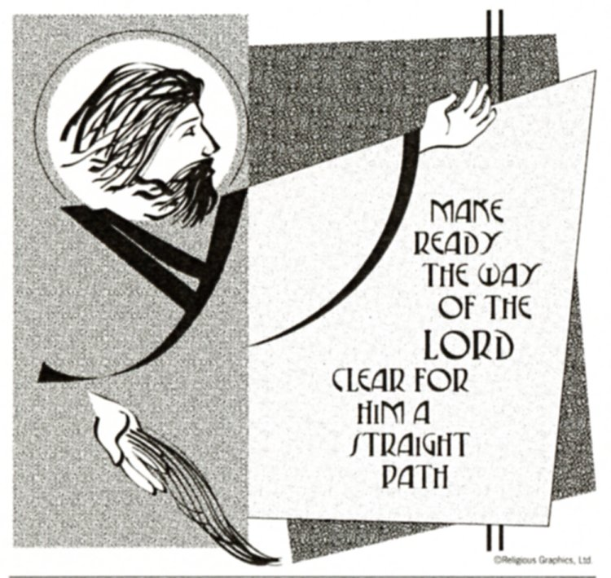

**SUNDAY MASS 10:00AM**

**SAT. VIGIL MASS 4:00PM**

**WEEKDAY MASS** **7:45AM**

**RECONCILIATION Saturday: 3:15 – 3:45PM**

**WEBPAGE:**  [www.strosechurchil.com](http://www.strosechurchil.com)

**EMAIL:** [belpsros@outlook.com](mailto:belpsros@outlook.com)

**FACEBOOK: St. Rose Catholic Church – St. Rose, IL**

**MASS WILL BE LIVE STREAMED ON OUR FACEBOOK PAGE SATURDAYS AT 4PM**

**SUNDAY COLLECTIONS:**

CCHD: $20.00 Weekly Envelopes: $3,083.00

Thanksgiving: $1,369.00 Sister Parish: $ 109.00

All Saints: $5.00 Capital Improvement Fund: $1,508.00

Immaculate Conception $50.00 Religious Retirement: $ 30.00

**MASS:** **INTENTIONS:**

Mon 7:45AM Immaculate Conception of Blessed Virgin Mary John & Bea Tebbe

Tue 7:45AM Advent Weekday NO MASS

Wed 7:45AM St. Damasus Butch & Joan Kohlbrecher

Thu7:45AM Our Lady of Guadalupe NO MASS

Fri 7:45AM St. Lucy Larry Straeter

Sat 4:00PM Vigil: Third Sunday of Advent L/D Joe & Mary Lou Fischer Family

“ “ “ L/D Ray & Edwina Tebbe Family

“ “ “ Jerome, Lorene & Brad Rehkemper

Sun 10:00AM Third Sunday of Advent For the Parish

**SERVERS:**

Sat Dec 14 4:00PM Seth Lane, Aubrey Thole, Bryna Harrison, Bria Tebbe

Sun Dec 15 10:00AM Elsie Thole, Paityn Fuhler, Ruby Jansen, Brady Jansen

**READERS:** Sat Dec 14 4:00PM Peggy Thole Sun Dec 15 10:00AM Myrt Rollins

**EUCHARISTIC MINISTERS:**

Sat Dec 14, 4:00PM Rose Jansen Sun Dec 15, 10:00AM Julie & Duane Bruggemann

**OFFERTORY:**

Sat Dec 14 4:00PM Fischer, Tebbe & Rehkemper Families

Sun Dec 15 10:00AM Paul Meyer, Ed Schrage, Paul Thole

**VOCATION CUP**: The next family to receive the Vocation Cup is the Daniel Diekmann Family .

**SYMPATHY:** Our sympathy to the family of Maurice “Moe” Buehne who passed away on

Tuesday, November 26th. Moe was the husband of Karen (Rehkemper) Buehne and the

brother of Linus (Deb) Buehne and the brother-in-law of Carol (Ron) Kohlbrecher.

May Moe enjoy the reward of eternal life.

**SYMPATHY:** Our sympathy to the family of Mary Ann Hempen who passed away on Sunday,

December 1st. Mary Ann was the mother of Mark Hempen, Debra (Mike) Gall and Larry (Tracy) Hempen. She was the grandmother of Nathan Gall (Emily) Gall, Amanda (Craig) Heinzmann, Jessie and

Nicole Hempen and Phillip Gall. The great grandmother of Ellie and Charlie Gall and Emma & Maryn Heinzmann and the sister-in-law of Cecilia Wilke. May Mary Ann enjoy the reward of eternal life.

**SYMPATHY:** Our sympathy to the family of Lavern Kuhl. Lavern, who passed away recently, was

the father-in-law of Deacon Linus (Sue) Klostermann. May Lavern enjoy the reward of eternal life.

**SYMPATHY:** Our sympathy to the family of Florence Usselman. Florence, who passed away

recently, was the sister-in-law of Nick Timmermann, Sr. May Florence enjoy the reward of eternal life.

**BIRTHDAYS:**

Dec 10 Samantha Faust Dec 12 Lacey Benhoff Dec 14 William Timmermann III

Dec 10 Donald Fuhler Dec 12 Marvin Frohn Dec 14 Joanie Willis

Dec 10 Landon Hilmes 13 Dec 14 Brad Leezer Dec 15 Alex Diekmann

Dec 11 Adam Jansen Dec 14 Hannah Poettker 9

Dec 11 Logan Straeter Dec 14 Jared Tebbe

**VOCATIONS CORNER:**

“I had many kinds of exotic pets as a kid and was always fascinated by the mysteries of nature. I was

equally drawn to the ungraspable mystery of God. Though I grew up Catholic, I didn’t know much about my faith or have a deep prayer life. In college, I studied biological anthropology and encountered ideas

that I thought were inconsistent with belief in God. Faith became doubt: I tried praying and going to

Mass but the mystery of God I was once drawn to seemed an illusion. By God’s providence, I found

myself at Holy Thursday Mass a few months later. The moment I saw the priest washing the people’s

feet, I became overwhelmed with God’s love for me. He spoke to my unbelieving heart, placing in it

a call that enveloped my being with a new purpose: to join that priest in leading others to an encounter

with God. I was ordained in 2019 and now use my pets to bring others....to a greater appreciation of

God’s creation.” Fr. Carlos Orozco; Diocese of Seattle.

**CHRISTMAS GIFTS FOR THE NEEDY:**

**PLEASE**, return your gift no later than **THIS** Sunday, December the 8th.

We also have envelopes with donations for Catholic Relief Service if you wish to donate to them.

**DECORATING OF THE CHURCH FOR CHRISTMAS:**

This year the decorating of the church will be after the 10AM Mass **THIS** Sunday, Dec. 8th.

Any and all help is appreciated!

**ST. ROSE ADVENT RECONCILIATION SERVICES:**

Tuesday, December 10th at 7:00PM

**ATTENTION QUILTERS:** Quilting will begin again in January. More information to come.

**HEARTLAND COMMUNITY CHORUS CHRISTMAS CONCERT:**

**THIS** Sat Dec 14 at 7PM and Sunday, Dec 15 at 3PM at St. Paul Church in Highland.

Tickets $15 (sixteen & under are free) Can be purchased on line, at the door or from any chorus member.

“HAVE YOU REMEMBERED ST. ROSE PARISH IN YOUR ESTATE PLANNING?”