**ST. ROSE CHURCH**

**ST. ROSE, IIlinois**

**Fr. Edward F. Schaefer**

18010 St. Rose Road

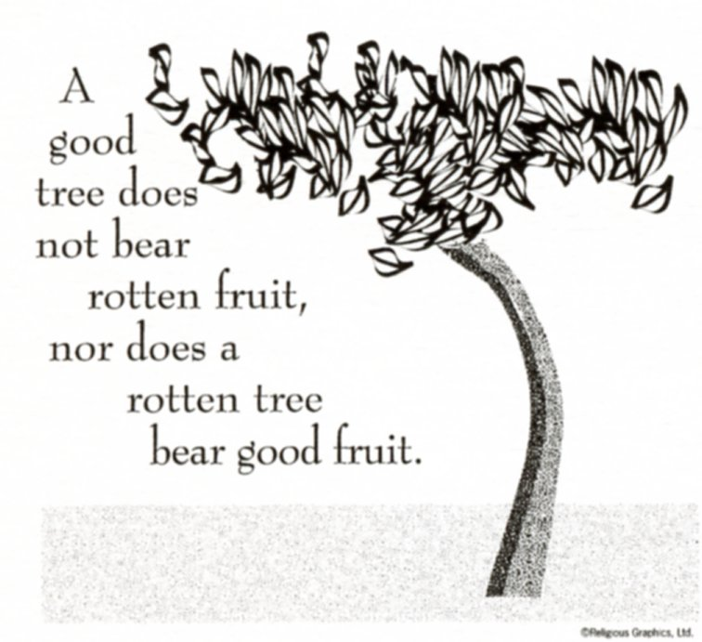

526-4118 Rectory

**SUNDAY MASS 10:00AM**

**SAT. VIGIL MASS 4:00PM**

**WEEKDAY MASS** **7:45AM**

**RECONCILIATION Saturday: 3:15 – 3:45PM**

**WEBPAGE:**  [www.strosechurchil.com](http://www.strosechurchil.com)

**EMAIL:** [belpsros@outlook.com](mailto:belpsros@outlook.com)

**FACEBOOK: St. Rose Catholic Church – St. Rose, IL**

**MASS WILL BE LIVE STREAMED ON OUR FACEBOOK PAGE SATURDAYS AT 4PM**

**SUNDAY COLLECTIONS:**

Weekly Donations: $ 3,008.00 Sister Parish: $ 5.00

Capital Improvement Fund: $ 620.00

**MASS TIMES** **MASS INTENTIONS:**

Mon 7:45AM Weekday NO MASS

Tue 7:45AM Weekday NO MASS

Wed 7:45AM Ash Wednesday Joan Kohlbrecher

Wed 7:00PM Ash Wednesday Terry Kampwerth

Thu 7:45AM St. Gregory of Narek NO MASS

Fri 7:45AM Weekday Vince Klostermann

Sat 4:00PM Vigil: Eighth Sunday in Ordinary Time Jo Ann Vonder Haar

L/D Erwin & Christine Holtgrave

Francis Wilke

Sun 10:00AM: Eighth Sunday in Ordinary Time For the Parish

**SERVERS:**

Wed Mar 5 7:00 PM Augie Benhoff, Theo Tebbe, Zane Tebbe, Bria Tebbe

Sat Mar 8 4:00PM Alaina Schrage, Theo Tebbe, Ava Hilmes, Isabella Goebel

Sun Mar 9 10:00AM Wyatt Stock, Wade Kramer, Briggs Kramer, Tinsley Schwierjohn

**READERS:** Wed Mar 5 7:00PM Mary Lou Voss Sat Mar 8 4:00PM Brenda Niedzwiecki

Sun Mar 9 10:00AM Myrt Rollins

**EUCHARISTIC MINISTERS:** Wed Mar 5 7:00PM Paul Meyer Sat Mar 8 4:00PM Jean Tebbe

Sun Mar 9 10:00AM Julie Bruggemann & Marilyn Bruggemann

**OFFERTORY:** Wed Mar 5 7:00 PM Kampwerth Family

Sat Mar 8 4:00PM VonderHaar, Holtgrave, & Wilke Families

Sun Mar 2 10:00AM Paul Meyer, Matt Benhoff, Jesse Thole

**VOCATION CUP**: The next family to receive the Vocation Cup is the Mary Lou Fischer Family.

“HAVE YOU REMEMBERED ST. ROSE PARISH IN YOUR ESTATE PLANNING?”

**CONGRATULATIONS:** To Ivy Leigh Robke who was Baptized here last weekend. Ivy is the daughter of Calvin & Erin (Bruggemann) Robke . Many blessings to her!

**CONGRATULATIONS:** To Porter Wayne Hove who was Baptized here last weekend. Porter is the son of Conner & Michaela (Rund) Hove. Many blessings to him!

**CONGRATULATIONS:** To Palmer Grace Hove who was Baptized here last weekend. Palmer is the daughter of Chase & Aubrey (Ricketts) Hove . Many blessings to her!

**ANNIVERSARIES:**

Mar 3 Nathan & Emily Gall Mar 7 Darrell & Christina Klenke

Mar 8 Chad & Jill Vonder Haar

**BIRTHDAYS:**

Mar 3 Jason Bange Mar 5 Michael Schumacher Mar 8 Lisa Baer

Mar 3 Rylan Schneider 10 Mar 5 Rebecca Wiegmann Mar 8 Jay Fuhler

Mar 3 Jennifer Schrage Mar 6 Kinsley Emig 5 Mar 8 Ansley Mollet 10

Mar 4 Randy Buehne Mar 6 Corben Rehkemper 9 Mar 8 Amelia Tebbe

Mar 4 Zackary Martin Mar 6 Hayden Winkeler 1 Mar 9 Blake Fuhler

Mar 4 Lindsay McCray Mar 7 Kayden Barriger, Jr 16 Mar 9 Collen Mollet 5

Mar 4 Cliff Schuette Mar 7 Emma Mueller Mar 9 Nicholas Sturgeon 12

Mar 5 David Erlinger Mar 7 Nathan Tebbe

Mar 5 Anna Knebel Mar 7 Brianna Tebbe 14

Mar 5 Brenda Niedzwiecki Mar 8 Raegan Alberternst 13

**ST. ROSE FISH FRY:**  Ash Wednesday and Every Friday through Good Friday. St. Rose Development Park. Drive Thru 4-7. Work List is located at Wessels.

**CEMETERY:** Please remove grave blankets from plots as soon as possible.

**A GREAT OPPORTUNITY FOR YOUR LENT THIS YEAR!**

A Video Series on the Gospel of LUKE: THE STORY OF SALVATION FULFILLED! Each TUESDAY

during Lent at 7PM in the Development Club Building beginning March 11th. This special series will enrich your everyday life. JOIN US AND BRING A FRIEND. Call Marilyn Bruggemann 618-210-1258 or

Myrt Rollins 314-707-7063.

**IMMACULATE CONCEPTION CHURCH, PIERRON DRIVE-THROUGH CHICKEN DINNER;**

Sunday, March 2nd 11AM to 5PM. All dinners $15.

**VICARIATE:** The Vicariate Healing Mass is at St. George, New Baden on March 18th. Confessions at 6:00PM with Mass at 7:00PM.

**BREESE K of C:** The Breese Council will be starting a Men’s Fraternal Program called Cor on March 8th at Mater Dei High School. Men are welcome to join these meetings based on Prayer, Formation, and Fraternity. Contact Bill Rauen at [william.rauen1@gmail.com](mailto:william.rauen1@gmail.com).

**HEARTLAND COMMUNITY CHORUS:** Spring Concert, “Going Over Jordan”, featuring guest soprano soloist Christine Brewer. Saturday, March 22, 7:00PM at St. Paul United Church of Christ, 123 Dee St., Lebanon, and Sunday, March 23, 3:00PM St. Paul Catholic Church, Highland. Tickets are $15 (16 and under are FREE) and available at heartlandcommunitychorus.org, from chorus members, or at the door.