**ST. ROSE CHURCH**

**ST. ROSE, IIlinois**

**Fr. Edward F. Schaefer**

18010 St. Rose Road

526-4118 Rectory

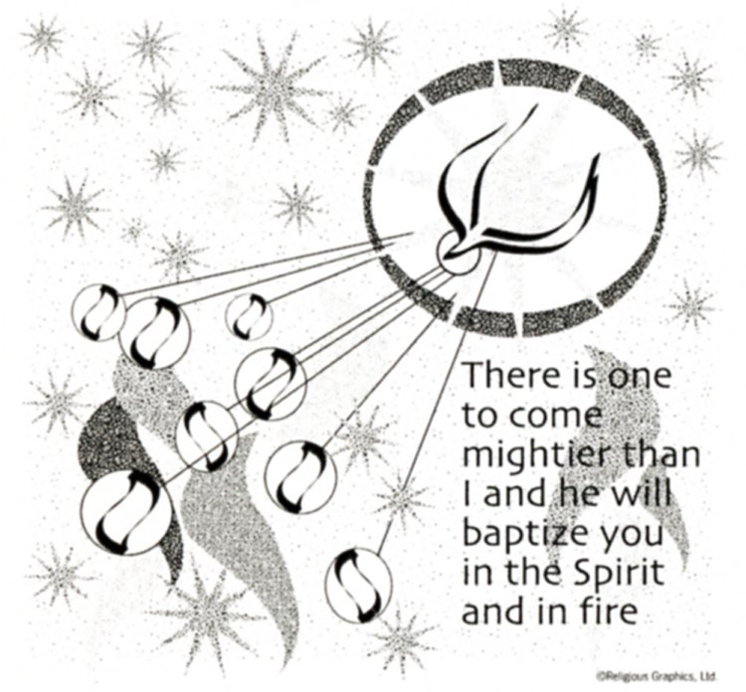

**SUNDAY MASS 10:00AM**

**SAT. VIGIL MASS 4:00PM**

**WEEKDAY MASS** **7:45AM**

**RECONCILIATION Saturday: 3:15 – 3:45PM**

**WEBPAGE:**  [www.strosechurchil.com](http://www.strosechurchil.com)

**EMAIL:** [belpsros@outlook.com](mailto:belpsros@outlook.com)

**FACEBOOK: St. Rose Catholic Church – St. Rose, IL**

**MASS WILL BE LIVE STREAMED ON OUR FACEBOOK PAGE SATURDAYS AT 4PM**

**SUNDAY COLLECTIONS:**

Thanksgiving: $205.00 Weekly Envelopes: $ 5,311.00

Christmas: $50.00 Sister Parish: $ 113.00

All Saints: $50.00 Capital Improvement Fund: $ 1,010.00

Immaculate Conception $905.00 Religious Retirement: $ 197.00

Christmas for the Needy: $300.00

**MASS:** **INTENTIONS:**

Mon 7:45AM Advent Weekday NO MASS

Tue 7:45AM Late Advent Weekday NO MASS

Wed 7:45AM Late Advent Weekday Gene Buehne

Thu7:45AM Late Advent Weekday NO MASS

Fri 7:45AM Late Advent Weekday Jeanette Rehkemper

Sat 4:00PM Vigil: Fourth Sunday of Advent L/D Frank & Elsie Thole Family

“ “ “ Ray, Edwina and Tom Tebbe Family

“ “ “ Alex Schrage

Sun 10:00AM Fourth Sunday of Advent For the Parish

**SERVERS:**

Sat Dec 21 4:00PM Aubree Ribbing, Michael Ribbing, Aubrey Thole, Ava Hilmes

Sun Dec 22 10:00AM Wyatt Stock, Tinsley Schwierjohn, Senya Rahden, Luci Kuper

**READERS:** Sat Dec 21 4:00PM Jeff Kampwerth Sun Dec 22 10:00AM Mabry Benhoff

**EUCHARISTIC MINISTERS:**

Sat Dec 21, 4:00PM Linda Habermehl Sun Dec 2, 10:00AM Jean Tebbe & Jesse Thole

**OFFERTORY:**

Sat Dec 21 4:00PM Thole, Tebbe & Schrage families

Sun Dec 22 10:00AM Gary Tebbe, Tim Droege, Jay Fuhler

**VOCATION CUP**: The next family to receive the Vocation Cup is the Tim Droege Family .

**SYMPATHY**: Our sympathy to the family of Patricia “Pat” Baer. Pat, who passed away recently, was

the mother of Eric (Lisa) Baer and the grandmother of Gavyn and Nadia Baer and step grandmother of

Jonah (fiance, Elina) Toennies. May Pat enjoy the reward of eternal life.

**SYMPATHY:** Our sympathy to Jonathan (Christina) Gall who is the grandson of Mary Ann Hempen and to Lena & Lucy Gall who are great-grandchildren of Mary Ann Hempen. They were omitted from last week’s bulletin. (I’m sorry!)

**SYMPATHY:**  Our sympathy to the family of Jennifer Kalmer. Jennifer, who passed away recently, was the daughter of Ruth Holmes and the step daughter of James Holmes. She was the niece of Pat (Myrt) Rollins, Norbert (Marilyn) Thole, Marcellus Thole and Kenny (Diane) Thole. May Jennifer enjoy the reward of eternal life.

**SYMPATHY:** Our sympathy to the family of William Timmermann. William, who passed away recently,

was the uncle of Vernon Korte, Rene (Kenny) Wilke, Laura (Matt) Benhoff, Kevin Grapperhaus,

Judy Spihlmann, Lorraine Henrichs & Gary (Carlene) Rosen. May William enjoy the reward of eternal life.

**ANNIVERSARIES**: Dec 21 Adrian & Alexis Tehandon ‘2020

**BIRTHDAYS:**

Dec 17 Amanda Benhoff Dec 19 Krystal Gruenenfelder Dec 21 Emmett Buehne 2

Dec 17 Jason Fuhler Dec 19 Randy Schrage Dec 21 Elizabeth Eilers

Dec 17 John J. Kalmer 7 Dec 19 Martin Schumacher Dec 21 Kris Jeckstadt

Dec 17 Karen Kaufman Dec 19 Jesse Thole Dec 21 Brett Richter

Dec 17 Norbert Thole Dec 20 Laura Gall Dec 21 Jared Thole

Dec 18 Lucy Gall 6 Dec 20 Joshua Henrichs Dec 21 Riggs Wilke 1

Dec 18 Mary Jane Schrage Dec 20 Agnes Korte Dec 22 Jason Scott

Dec 18 Genevieve Thole Dec 20 Dale Whitlatch Dec 22 Brady Timmermann

Dec 19 Carl Gall Dec 20 Bonnie Wilke Dec 22 James Voss

**VOCATIONS CORNER:**

Today’s Gospel details the 2nd Joyful Mystery of the Rosary – The Visitation. Mary has accepted

HER call to be the Mother of God. And even though pregnant, she travels to visit Elizabeth who

is the mother of John the Baptist. Elizabeth tells her “Blessed are you who believed that what was

spoken to you by the Lord would be fulfilled.” Have you asked yourself if you are fulfilling what the

Lord has spoken to you? Are you being called to something special? Is that a call to the priesthood

or religious life?

**ADVENT RECONCILIATION:**

Sun Dec 15 St. Mary Mt. Vernon 1PM Sun Dec 15 St. Boniface, Germantown 2PM

Sun Dec 15 St. Francis, Aviston 6PM Thurs Dec 19 St. Mary, Carlyle 6PM

**CSMA MESSAGE FROM BISHOP MICHAEL MCGOVERN:**

“The true joy of Christmas is in the everlasting love of Christ. May you find His peace, love

and joy now and in the coming new year. With deepest gratitude for your prayers & generosity.”

**ST. VINCENT DE PAUL NEEDS COATS:**

Gently used or new coats of all types in all sizes for all ages – toddlers, children, teens & adults

(men and women) are being requested. Items can be dropped off at the St. Vincent de Paul office

located at 8800 West Main St., Belleville (across from Blessed Sacrament Church) or call Joe Hubbard

or Pat Hogrebe at 618-394-0126 for additional information.

**JUBILEE YEAR 2025:**

Pope Francis will open the Jubilee Year of 2025 by opening the Holy Door in St. Peter’s Basilica in

Rome on Christmas Eve. Join Bishop Michael McGovern in opening the celebration of the Jubilee

Year in our Diocese at the 10:30AM Mass at the Cathedral of St. Peter (200 W. Harrison), Belleville on Sunday December 29th. Our theme for the Jubilee Year is Pilgrims of Hope. For more information visit www.diobelle.org.

“HAVE YOU REMEMBERED ST. ROSE PARISH IN YOUR ESTATE PLANNING?”